## Object Oriented Programming

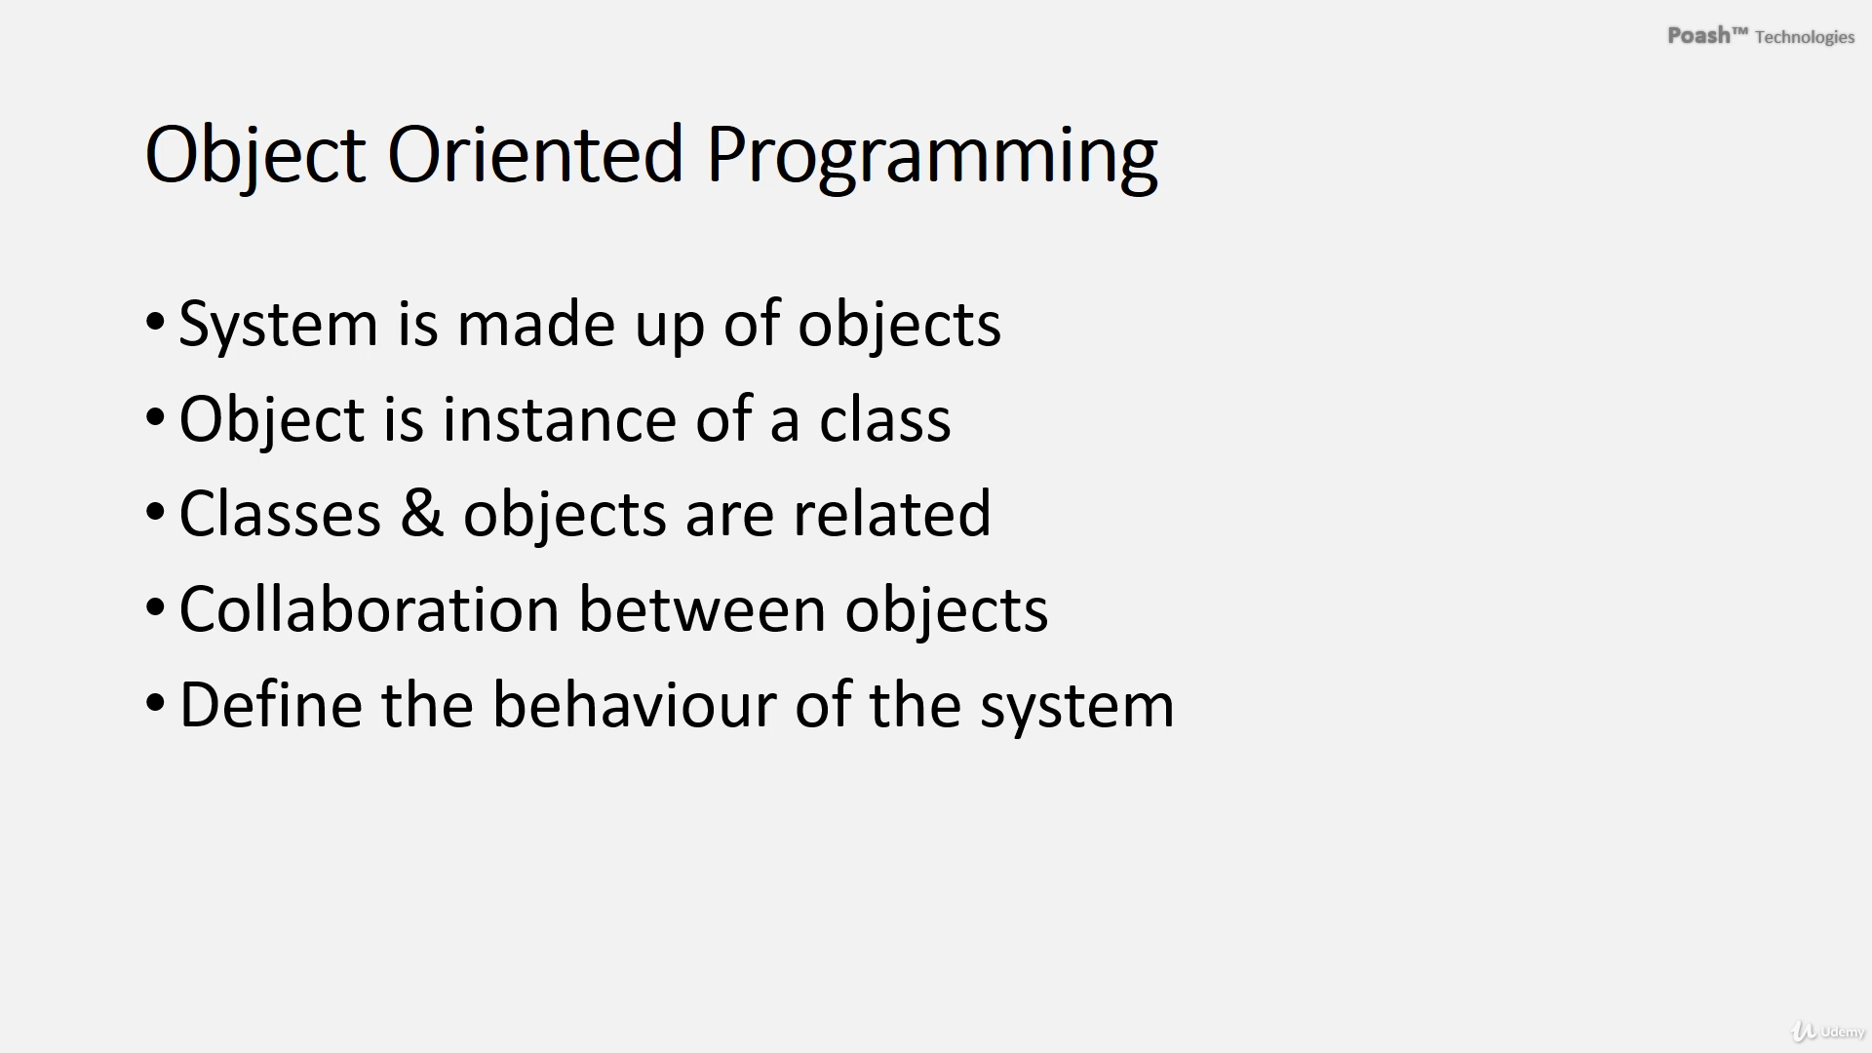

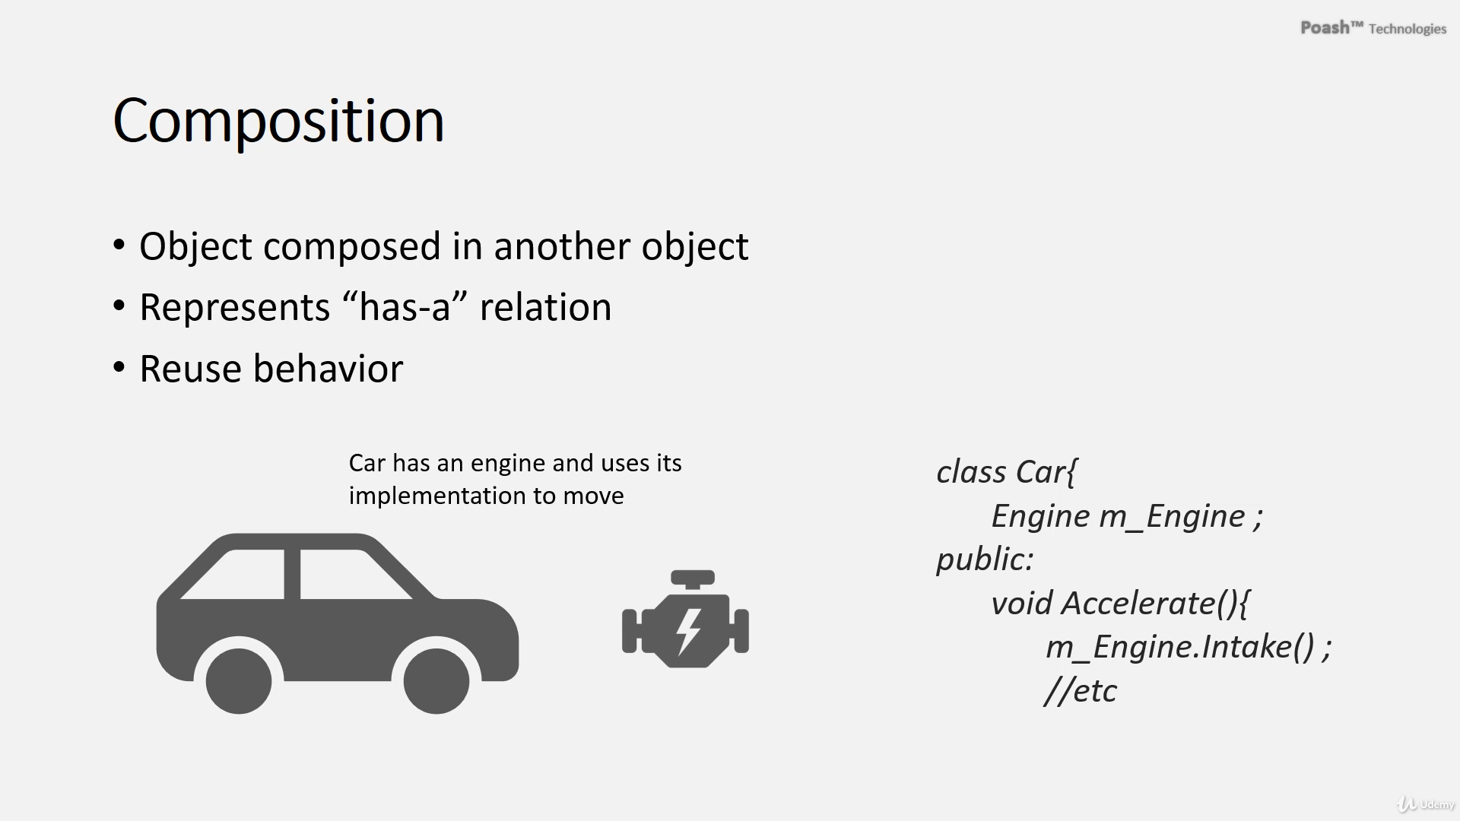

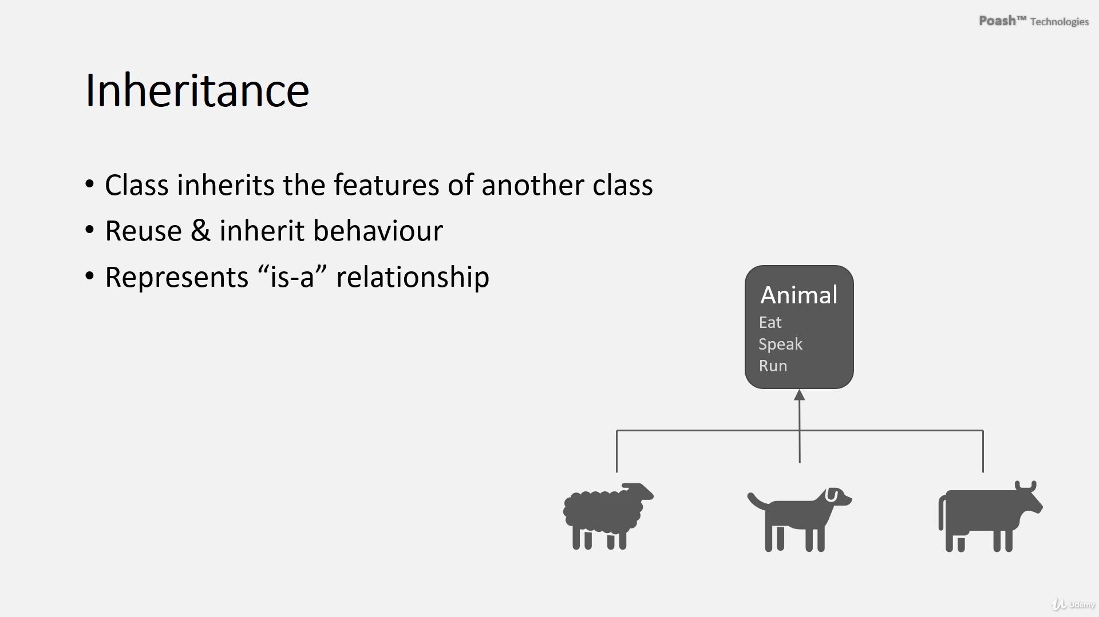

In object-oriented programming, establishing relationships between classes and objects is crucial for simulating real-world scenarios effectively. Two primary mechanisms for this are composition and inheritance.

* **Composition:** involves integrating an object into another, creating a whole-part relationship, often described as a **"has-a"** or **"part-of"** association. This approach promotes code reuse by allowing the outer object to leverage the functionality of the inner object. For example, a Car class might encapsulate an Engine object to achieve acceleration.
* **Inheritance:** enables a child class to inherit attributes and behaviors from a parent class, establishing an **"is-a"** relationship. This promotes code reuse by avoiding redundant implementation of common functionalities. For instance, specific animal classes like Sheep, Dogs, and Cows can inherit behaviors from a common Animal class.

In summary, both composition and inheritance are essential for establishing relationships in OOP, fostering collaboration, and promoting code reuse, leading to the development of robust and maintainable software systems.

**Inheritance**

**Inheritance** is a mechanism where a new class (derived class) is created from an existing class (base class). The derived class inherits the properties and behaviors (methods) of the base class, and it can also have additional properties and behaviors or override existing ones.

**Key Points**:

* **Is-a relationship**: The derived class is a type of the base class.
* Promotes code reuse by inheriting common functionality from base classes.
* Can lead to tightly coupled code if overused.

**Example in C++**:

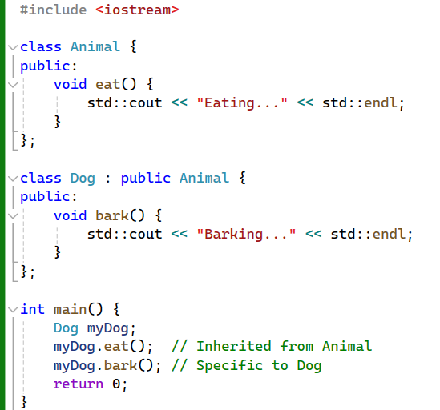

In this example:

* **Dog** inherits from **Animal**, meaning a **Dog** is an **Animal**.
* **Dog** can use the **eat()** method defined in **Animal**.

**Composition**

**Composition** is a design principle where a class is composed of one or more objects of other classes, meaning that the composed class "has" objects of other classes. This is known as a **has-a relationship**.

**Key Points**:

* **Has-a relationship**: The class contains objects of other classes.
* Promotes code reuse by containing instances of other classes.
* More flexible than inheritance as it allows for dynamic changes at runtime.
* Reduces tight coupling between classes.

**Example in C++**:

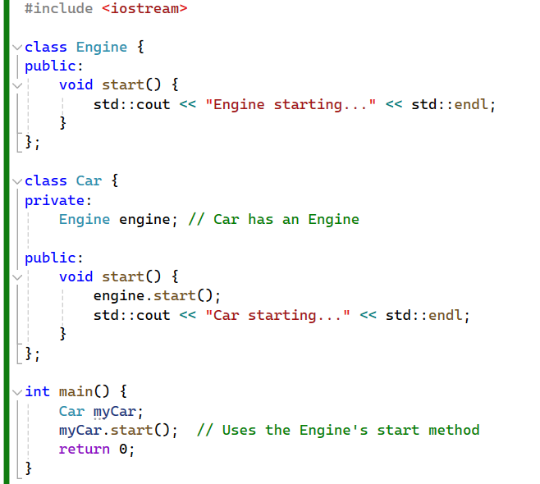

In this example:

* **Car** has an **Engine**, meaning **Car** is composed of an **Engine**.
* **Car** uses the **Engine**'s **start()** method within its own **start()** method.

**Differences between Inheritance and Composition**

1. **Relationship Type**:
   * **Inheritance**: Represents **an is-a relationship**. For example, a **Dog** is an **Animal**.
   * **Composition**: Represents **a has-a relationship.** For example, a **Car** has an **Engine**.
2. **Coupling**:
   * **Inheritance**: Can **create tight coupling between base and derived classes**, making it **harder** to change the base class without affecting derived classes.
   * **Composition**: Promotes **loose coupling** as changes to component classes typically do not affect the containing class.
3. **Flexibility**:
   * **Inheritance**: **Less flexible** because the class **hierarchy** is static. Once a class inherits from another, the relationship is fixed.
   * **Composition**: **More flexible** because you can **change the composed objects at runtime**, allowing for more dynamic and adaptable designs.
4. **Reusability**:
   * **Inheritance**: Reuses code by inheriting common functionality, but can be limited by the rigidity of the class hierarchy.
   * **Composition**: Reuses code by including instances of other classes, offering greater flexibility in how functionality is assembled.

**When to Use Inheritance vs. Composition**

* **Use Inheritance** when:
  + There is a **clear hierarchical** relationship.
  + You need to **extend or modify the behavior** of the base class.
  + You want **to use polymorphism**, where a base class reference can refer to objects of derived classes.
* **Use Composition** when:
  + You want to **assemble objects** to create more complex functionality.
  + You need greater **flexibility** and the ability to **change behavior at runtime**.
  + You want to **avoid** **the** **tight** **coupling of inheritance**.

**Combined Example**

Sometimes, you might use both inheritance and composition together to achieve a more robust design.

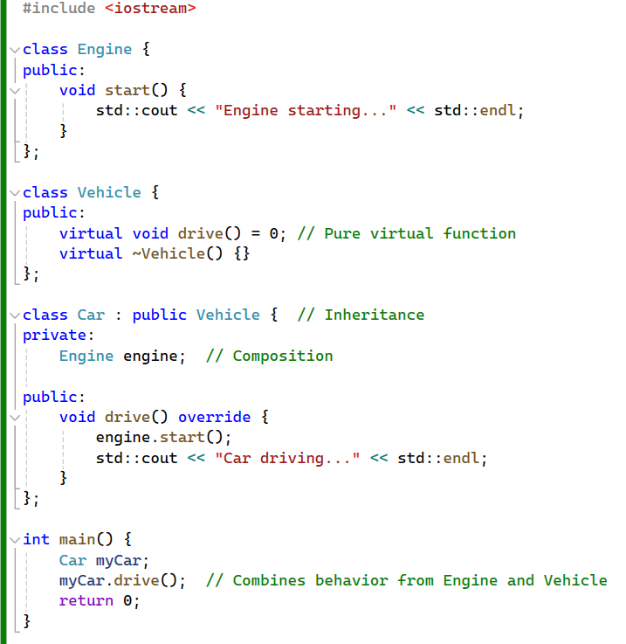

In this combined example:

* **Car** inherits from **Vehicle**, meaning a **Car** is a **Vehicle**.
* **Car** has an **Engine**, meaning a **Car** is composed of an **Engine**.
* This design leverages both inheritance (for polymorphism and hierarchy) and composition (for flexibility and modularity).

By understanding and effectively using both inheritance and composition, you can create more maintainable, flexible, and reusable object-oriented designs.

**Flexibility and Dynamic Changes at Runtime**

**Composition** provides more flexibility and allows for dynamic changes at runtime primarily because it relies on object references rather than a fixed class hierarchy. Here's why:

1. **Swapping Components**:
   * With composition, you can **change the components (objects) that a class uses at runtime**. This means you can swap out one implementation for another without changing the containing class. This is not possible with inheritance, as the class hierarchy is fixed at compile time.

**Example**: Consider a **Car** that has an **Engine**. You can change the **Engine** from a **PetrolEngine** to an **ElectricEngine** at runtime.

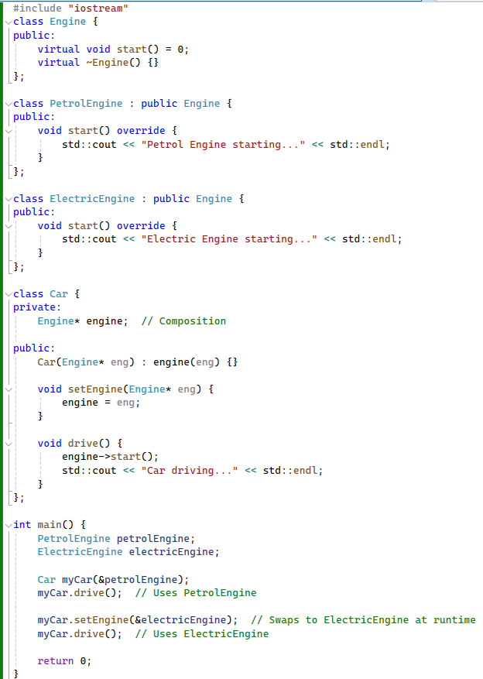

In this example, **Car** can **change its Engine at runtime**, demonstrating flexibility and dynamic behavior that is not achievable with inheritance.

1. **Decoupling Implementation from Interface**:
   * Composition allows you to **decouple** the implementation from the interface. You can design your **classes to depend on interfaces or abstract classes rather than concrete implementations**. This means you can change the concrete class used by an object without affecting the rest of the system.

**Example**: The **Engine** in the above example is an abstract class. **Car depends on the Engine interface, not on any specific implementation of Engine.**

**Coupling**

**Loose coupling** in composition means that changes to a component class do not necessarily affect the containing class, especially when the containing class interacts with the component class through an interface.

1. **Decoupled Interfaces**:
   * When you use composition and program to interfaces, the containing class **does not need to know about the specific implementation of the component**. This **reduces the dependencies** between classes.

**Example**:

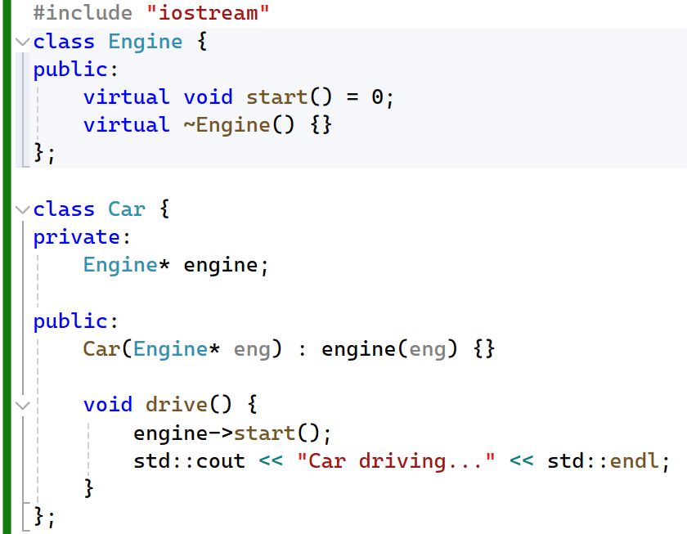

In this example, **Car** is decoupled from the specific implementation of **Engine**. Whether **Engine** is a **PetrolEngine**, **ElectricEngine**, or any other type of **Engine**, **Car** remains unaffected.

1. **Easier Maintenance**:
   * If you change the implementation of a component class, **as long as the interface remains the same**, the containing class does not need to change. This promotes easier maintenance and flexibility.

**Example**: If you modify **PetrolEngine** to have additional functionalities or a different internal logic, **Car** does not need to change as long as **PetrolEngine** still implements the **Engine** interface.

**Inheritance vs. Composition**

* **Inheritance**:
  + Creates a **strong relationship** between base and derived classes.
  + Tends to lead to **tightly coupled** code since derived classes are bound to the structure and behavior of base classes.
  + **Hierarchies are static**, making it **difficult** to change behavior at **runtime**.
  + Suitable when there is **a clear "is-a" relationship** and shared behavior.
* **Composition**:
  + Creates a **flexible relationship** where a class contains instances of other classes.
  + Promotes **loose coupling** by allowing changes to component classes without affecting the containing class.
  + Enables **dynamic behavior** by allowing components to be swapped or **modified at runtime.**
  + Suitable when there is **a "has-a" relationship** and when you want to decouple interfaces from implementations.

**Summary**

**Flexibility**:

* **Composition** allows for dynamic changes at runtime by enabling you to swap out components. This is achieved by having objects that reference other objects rather than being statically tied to a class hierarchy.

**Loose Coupling**:

* **Composition** promotes loose coupling by enabling classes to interact through interfaces. Changes to the implementation of a component class do not affect the containing class as long as the interface remains consistent.

By understanding these principles, you can design more adaptable and maintainable systems. Composition provides greater flexibility and decoupling, which is particularly useful in complex systems that require modularity and the ability to evolve over time.

# Inheritance Syntax & Access

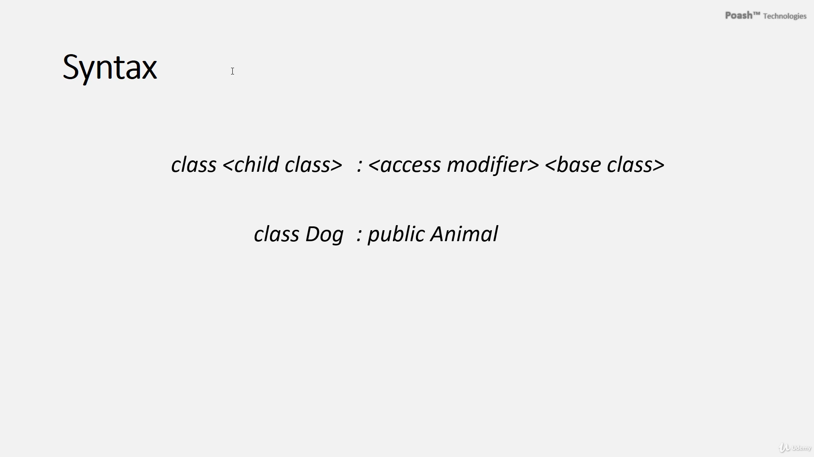

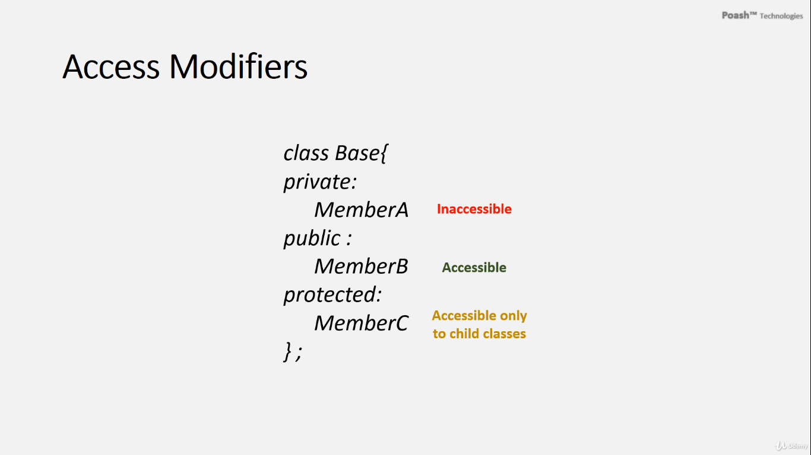

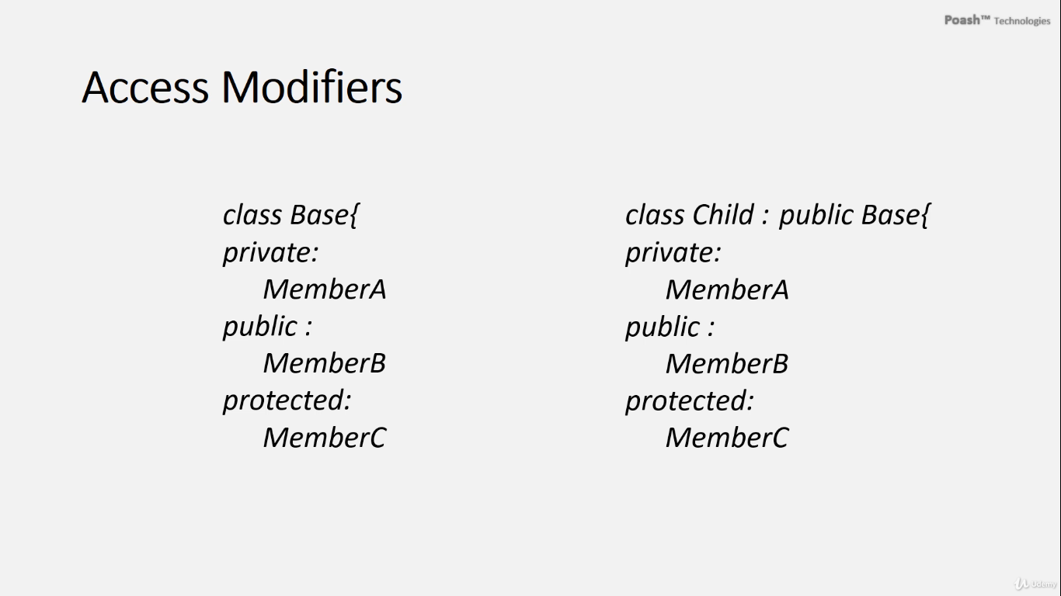

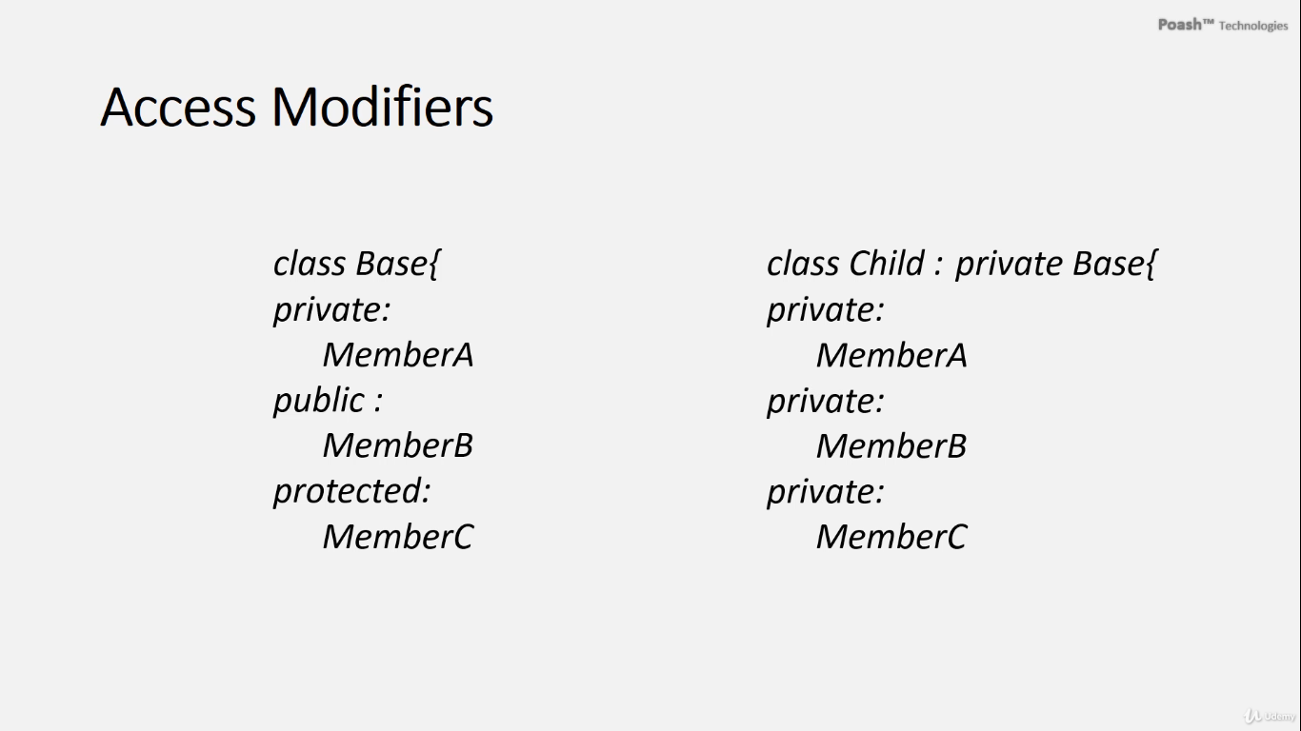

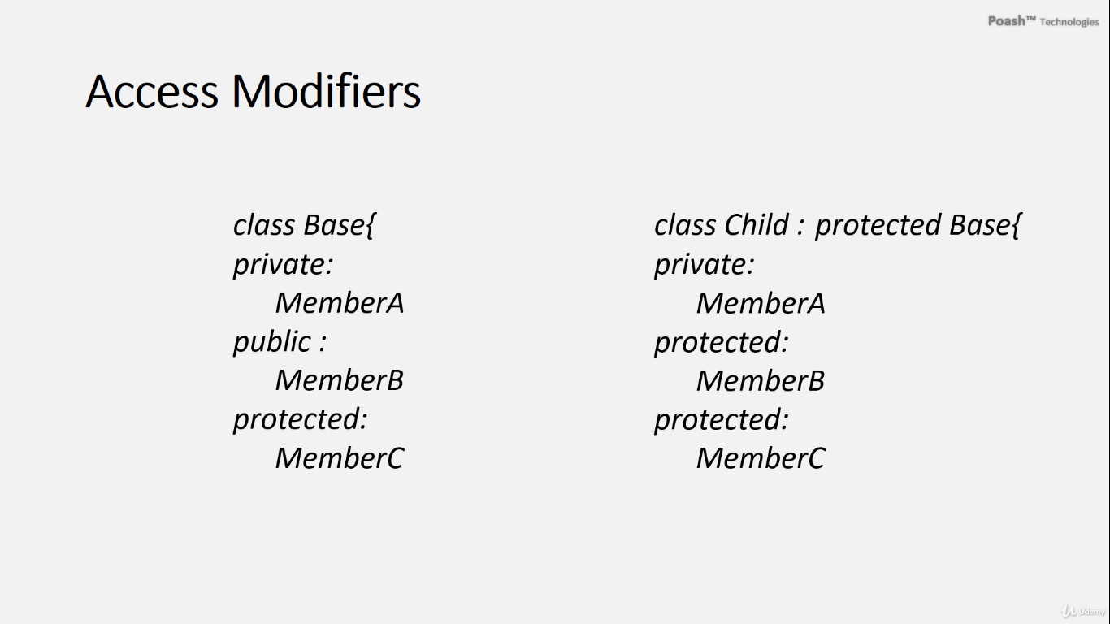

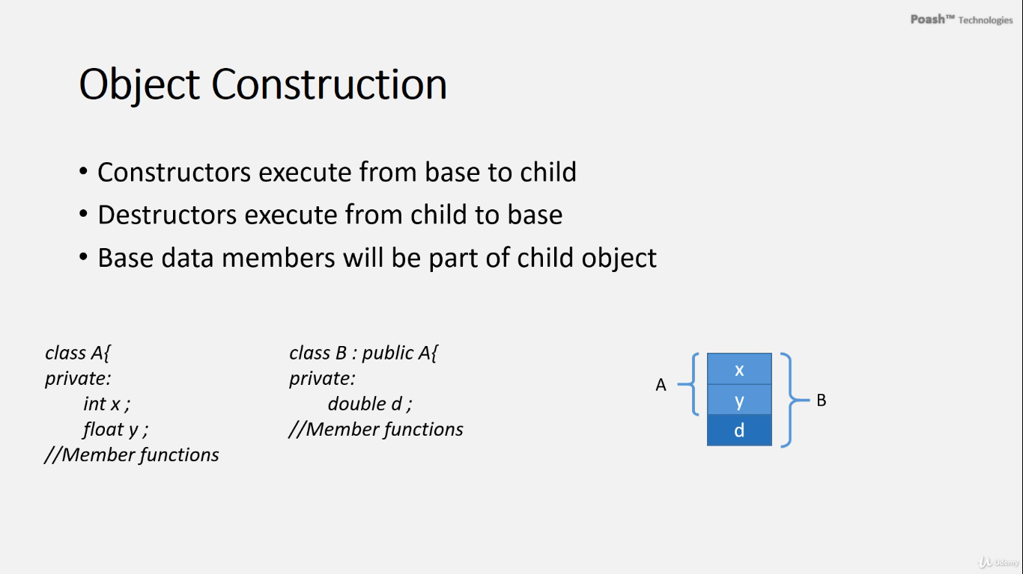

In C++, inheritance plays a vital role in establishing relationships between classes. When a class inherits from another class, it acquires the properties and behaviors of the base class. In the context of inheritance, access specifiers like public, private, and protected define how members of the base class are accessible to the derived class.

1. **Public Inheritance:** This is the most common form of inheritance. When a class **inherits publicly** from another class,

**the public members of the base class become public members** of the derived class,

**the protected members of the base class become protected members** of the derived class,

**the private members of the base class remain inaccessible to** the derived class. However, they are still present within the derived class.

1. **Private Inheritance:** With private inheritance, **all members of the base class become private members of the derived class**. This means that both public and protected members of the base class are accessible within the derived class, but they are not visible to outside entities.
2. **Protected Inheritance:** In this scenario, both **public and protected members** of the base class become **protected members of the derived** class. **The private members remain inaccessible** to the derived class, as with public inheritance.
3. **Default Inheritance:** If no access specifier is provided during inheritance, the default behavior depends on whether the derived class is a structure or a class.

* **If the derived class is a structure, the inheritance is public.**
* **If it's a class, the inheritance is private.**

Understanding these concepts of inheritance and access specifiers is crucial for designing robust and flexible object-oriented systems in C++.

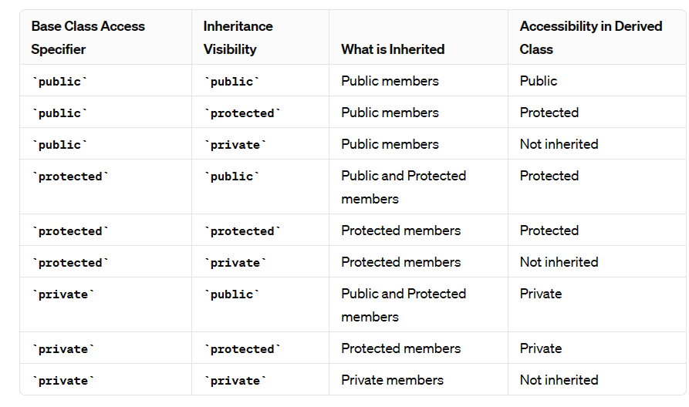

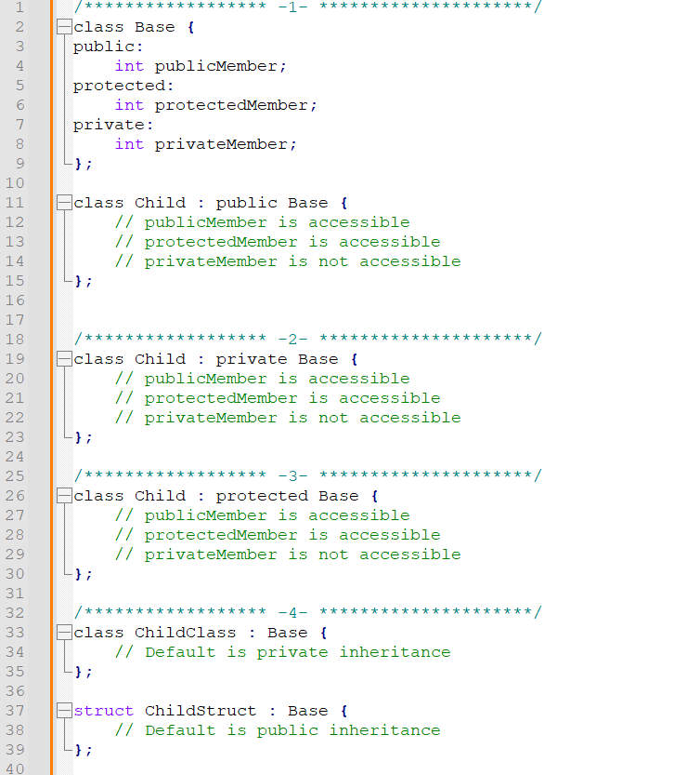

**What Does "Inaccessible" Mean for Private Members?**

* When private members are said to be "inaccessible" in the context of inheritance, it means that the derived class does not have direct access to these members.
* Private members are completely encapsulated within the base class and can only be accessed by the member functions of the base class.

**Private Members in Inheritance**

1. **Private Member Variables**:
   * Private member variables are declared with the **private** access specifier in a base class.
   * These variables are **not inherited** in a way that makes them accessible in the derived class. In other words, the derived class cannot access or modify these private member variables directly.
2. **Private Member Functions**:
   * Private member functions are declared with the **private** access specifier in a base class.
   * These functions are also **not inherited** in a way that makes them accessible in the derived class. The derived class cannot call these private member functions directly.

**Example to Illustrate Private Members**

Here is an example in C++ to illustrate the behavior of private members:

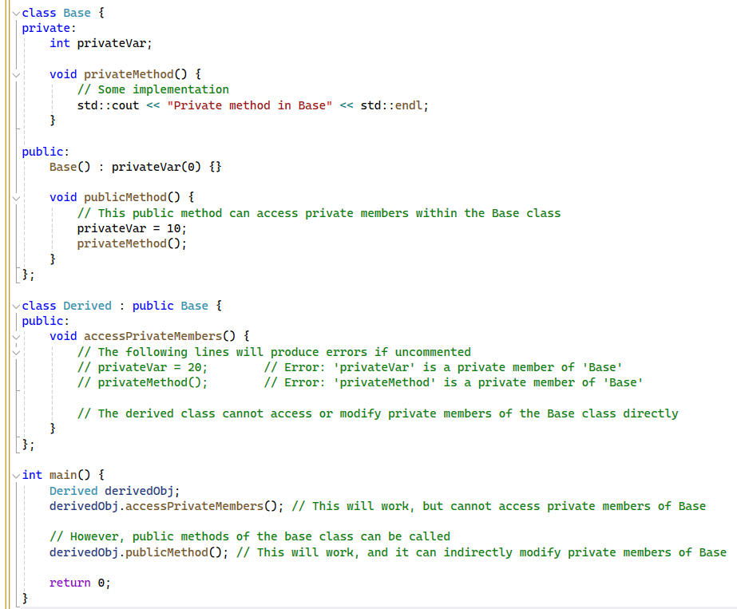

Encapsulation and abstraction are both fundamental concepts in object-oriented programming, but they serve different purposes and are used in distinct ways.

**Key Differences:**

1. **Purpose:**
   * **Encapsulation:** Focuses on hiding the internal state and protecting it from outside interference.
   * **Abstraction:** Focuses on hiding the complexity and exposing only the essential features.
2. **Implementation:**
   * **Encapsulation:** Implemented using access modifiers and methods to control access to data.
   * **Abstraction:** Implemented using abstract classes and interfaces to define common behavior.
3. **Visibility:**
   * **Encapsulation:** Involves making fields private and providing public methods to access them.
   * **Abstraction:** Involves defining a clear separation between what an object does and how it does it, often through abstract classes and interfaces.
4. **Use Cases:**
   * **Encapsulation:** Used to protect an object's state and ensure it is modified only through well-defined methods.
   * **Abstraction:** Used to create a simplified model of a system or process by focusing on high-level operations.

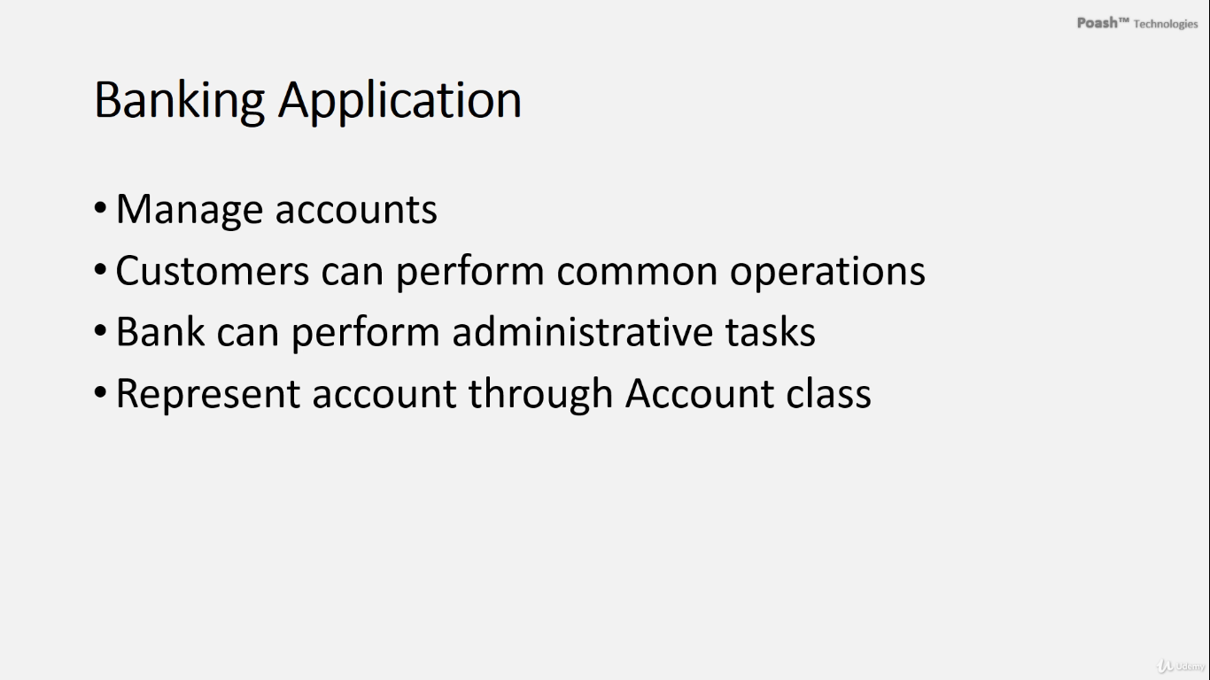

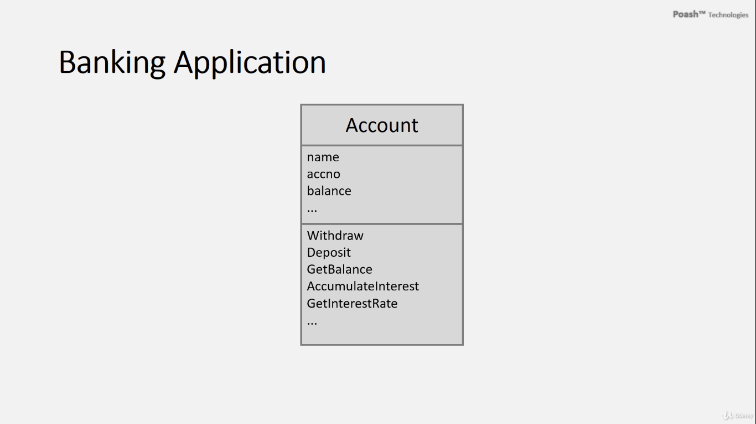

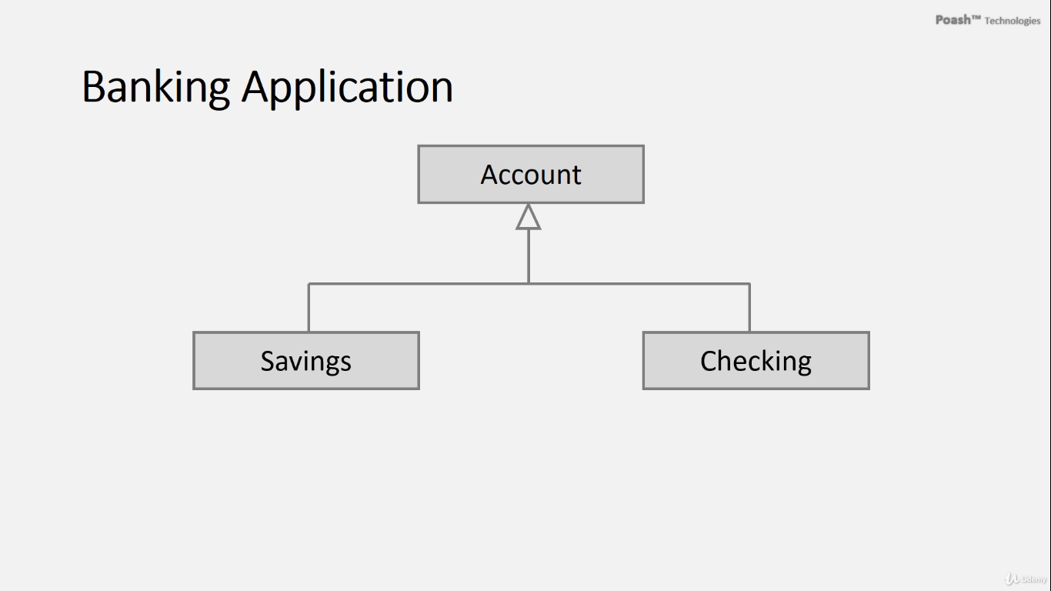

**Three member functions that are not inherited by derived classes are:**

1. Constructors
2. Destructors
3. Assignment operators

Therefore, when working with a derived class, these functions must be implemented explicitly. In C++11, however, it's possible to inherit constructors from the base class, allowing the compiler to automatically generate constructors in the derived class that call the corresponding base class constructors.

**To inherit constructors from the base class,** the **using** keyword is utilized. This enables the derived class to inherit and utilize the constructors defined in the base class without needing to redefine them manually.

**Using the using Keyword to Inherit Constructors**

When you use the **using** declaration in a derived class, it brings all constructors from the base class into the derived class. This allows the derived class to initialize itself using any of the base class constructors.

Here’s how it works:

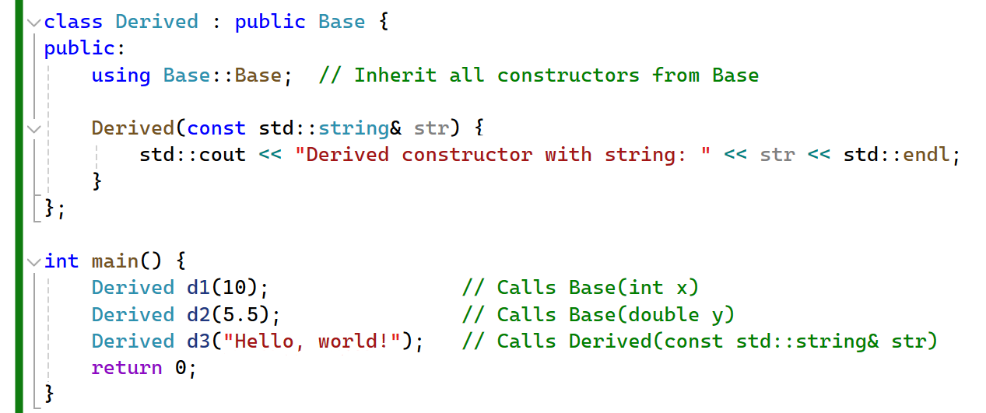**How It Works**

1. **Declaration**:
   * The **using Base::Base;** declaration in the **Derived** class brings all the constructors from the **Base** class into the **Derived** class.
2. **Initialization**:
   * When an object of the **Derived** class is created, it can use any of the constructors defined in the **Base** class, as if they were defined in the **Derived** class.

**Benefits**

* **Code Reusability**: It avoids code duplication, as you don’t have to manually redefine each constructor in the derived class.
* **Maintenance**: Makes the code easier to maintain and modify since changes in the base class constructors automatically apply to the derived class.
* **Simplification**: Simplifies the class definitions and improves readability.

**Important Notes**

* If the derived class needs to add its own additional behavior or members to its constructors, it can still define its own constructors explicitly.
* The **using** declaration for inheriting constructors will not inherit the default, copy, or move constructors unless these are explicitly defined in the base class.

Here is an example where the derived class defines its own constructor in addition to inheriting the base class constructors:

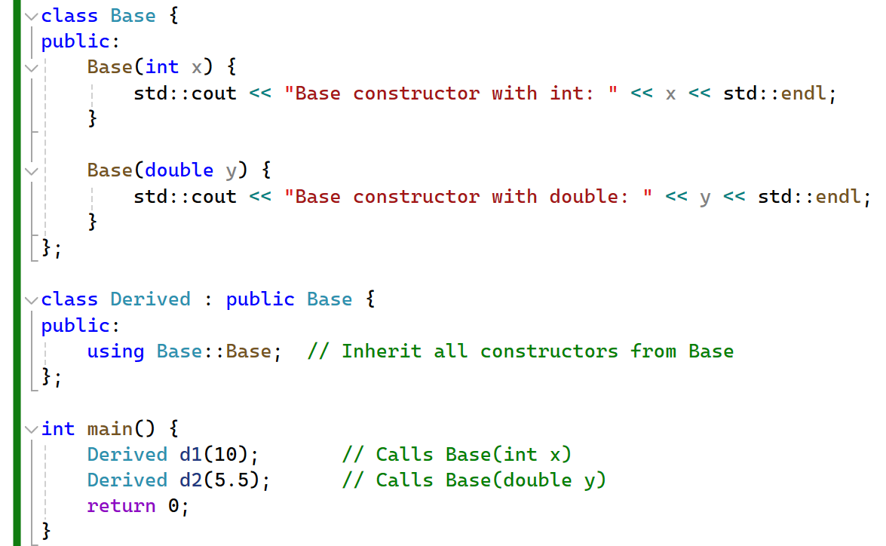

In this example, the **Derived** class has an additional constructor that takes a **std::string**, while still inheriting all the constructors from the **Base** class.

Using the **using** keyword in this manner provides a powerful and flexible way to manage constructors in class hierarchies, ensuring that derived classes can efficiently utilize base class functionality.

When you use the **using** declaration to inherit constructors from a base class in C++, it does not automatically inherit the default, copy, or move constructors unless these constructors are explicitly defined in the base class.

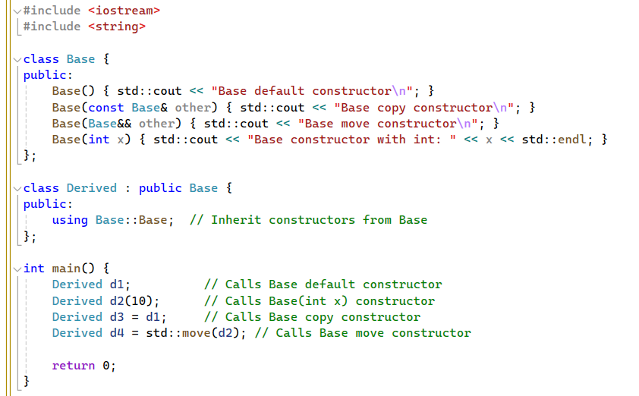

Here is an example where the base class does not explicitly define the copy and move constructors:

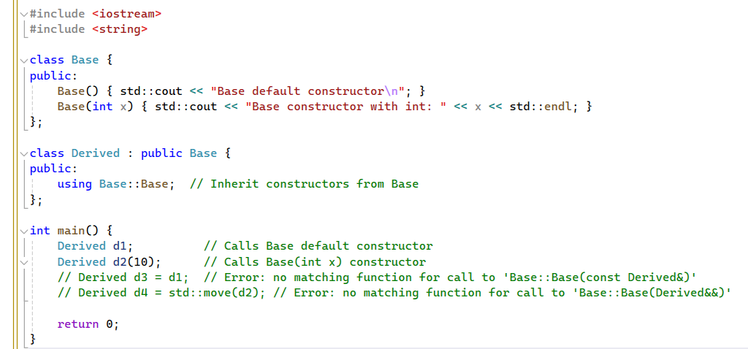

# The virtual keyword

In C++, the **virtual** keyword is crucial for marking a member function in a base class as virtual. When a function is tagged as virtual in a base class, it permits derived classes to override it with their own implementations. This capability facilitates **dynamic polymorphism**, where the appropriate function implementation is determined at runtime based on the object's type.

Polymorphism, the concept at play here, enables sending a message to an object that may represent various objects, ensuring that the message reaches the correct object and provides the expected behavior automatically. In our context, the functions **accumulateInterest**, **Withdraw**, and **getInterestRate** exemplify polymorphic behavior. Consequently, when these functions are called, they execute on the appropriate object pointed to by the account pointer.

The significant advantage of polymorphism lies in its ability to abstract away the specific object types from the code utilizing it. The code only needs knowledge of the base class, not the actual object type on which the functions are invoked. As a result, future addition of new account classes seamlessly integrates with the transaction module, which remains unaware of the child classes. The module solely interacts with the base class, **Account**.

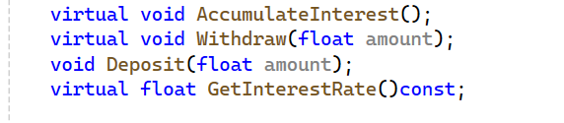

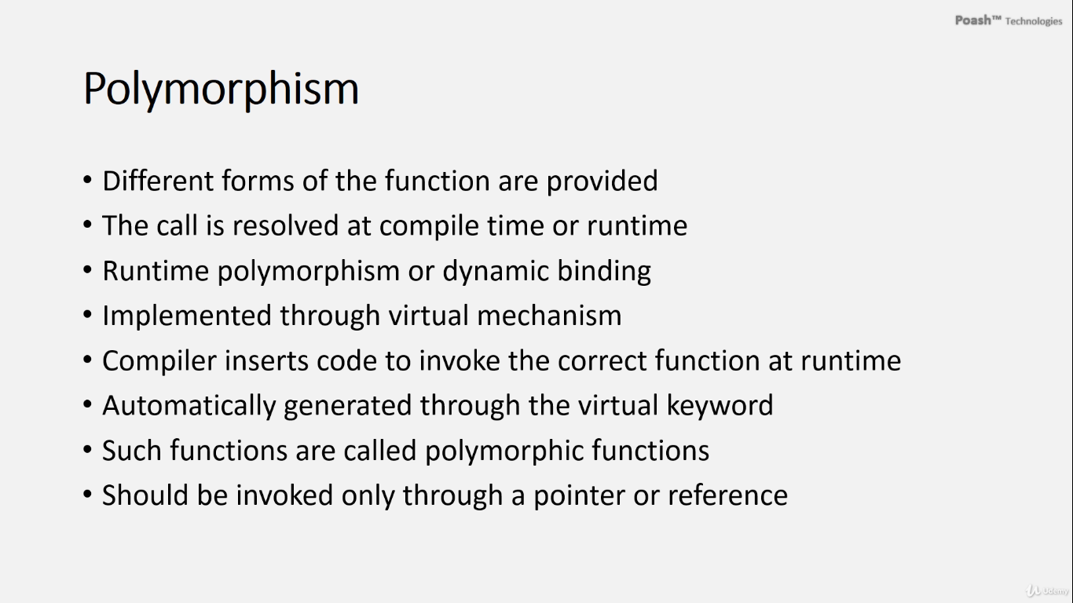

**Compile-Time Polymorphism**

Also known as static binding, compile-time polymorphism is determined during compilation. Common examples include:

* **Function Overloading**: Multiple functions with the same name but different parameters.
* **Operator Overloading**: Redefining operators for custom types.
* **Templates**: Allowing functions and classes to operate with generic types.

**Runtime Polymorphism**

Runtime polymorphism, or dynamic binding, is determined during program execution. It typically uses:

* **Virtual Functions**: Declared in a base class and overridden in derived classes.
* **Virtual Table (vtable)**: A table of function pointers used to invoke the correct function based on the object's dynamic type.

**Key Points**

* Polymorphic behavior relies on the dynamic type of the object, accessible through pointers or references to the base class.
* Using concrete objects for polymorphic function calls results in static binding, determined by the static type at compile time.

**Summary**

Polymorphism allows function invocation to be determined either at compile time (static binding) or runtime (dynamic binding), enhancing flexibility and adaptability in program design. The choice between compile-time and runtime polymorphism depends on specific program requirements and design considerations.

**Polymorphism in C++**

Polymorphism in C++ allows objects of different classes to be treated through a common interface. There are three main types of polymorphism in C++:

1. **Compile-time Polymorphism (Static Polymorphism)**
2. **Runtime Polymorphism (Dynamic Polymorphism)**
3. **Generic Programming (Templates)**

**1. Compile-time Polymorphism**

Compile-time polymorphism is **achieved through method overloading and operator overloading**. The correct method or operator **is determined at compile time**.

**Method Overloading**

Multiple methods with the same name but different parameter lists within the same class.

**Example**:

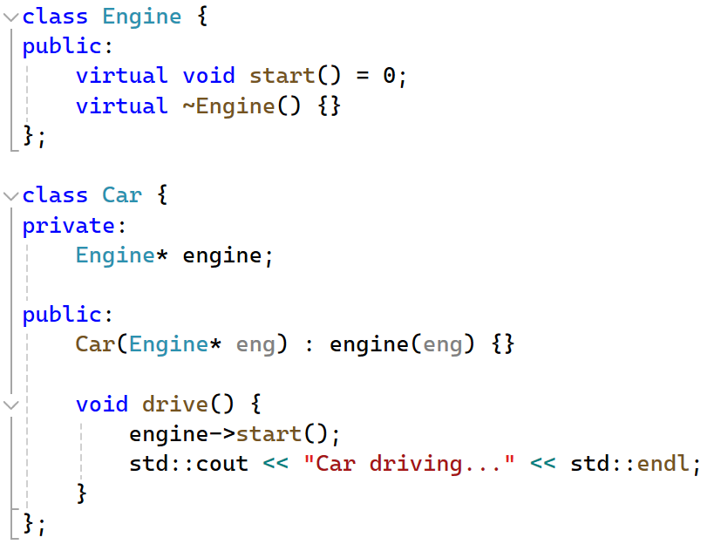

**Operator Overloading**

Defining custom behaviors for operators when applied to class objects.

**Example**:

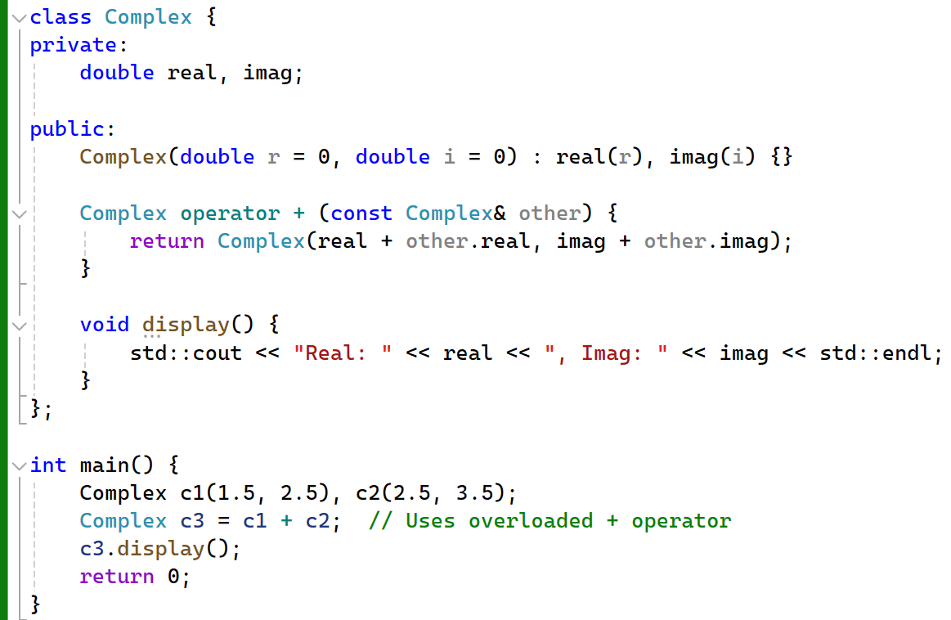

**2. Runtime Polymorphism**

Runtime polymorphism is achieved through **method overriding and interfaces** (abstract classes). The correct method is **determined at runtime**.

**Method Overriding**

A derived class provides a specific implementation of a method that is already defined in its base class. Achieved using virtual functions in C++.

**Example**:

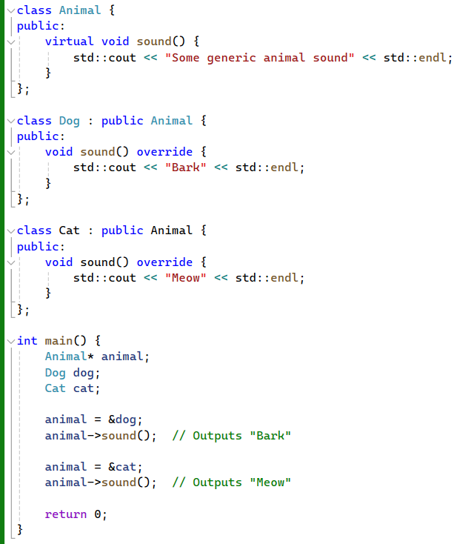

**Interfaces (Abstract Classes)**

Using abstract classes to define methods that derived classes must implement.

**Example**:

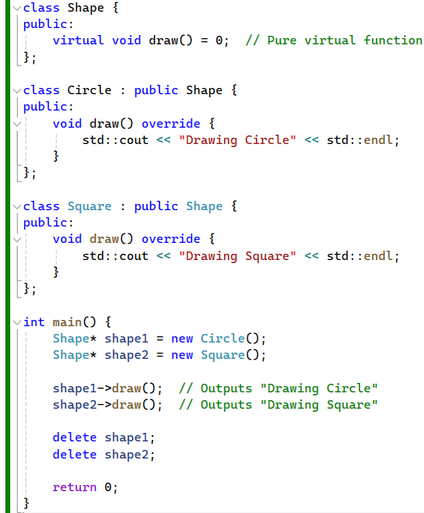

**3. Generic Programming (Templates)**

Templates allow functions and classes to operate with generic types. This means you can write a function or class that works with any data type.

**Templates** provide a form of polymorphism by enabling generic programming. This is achieved by writing code that can work with any data type.

**Function Templates**

Function templates allow you to define a function that operates on generic types.

**Example**:

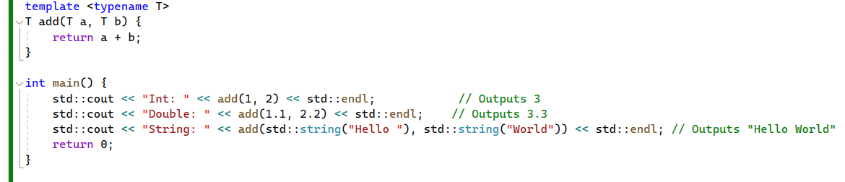

**Class Templates**

Class templates allow you to define a class that operates on generic types.

**Example**:

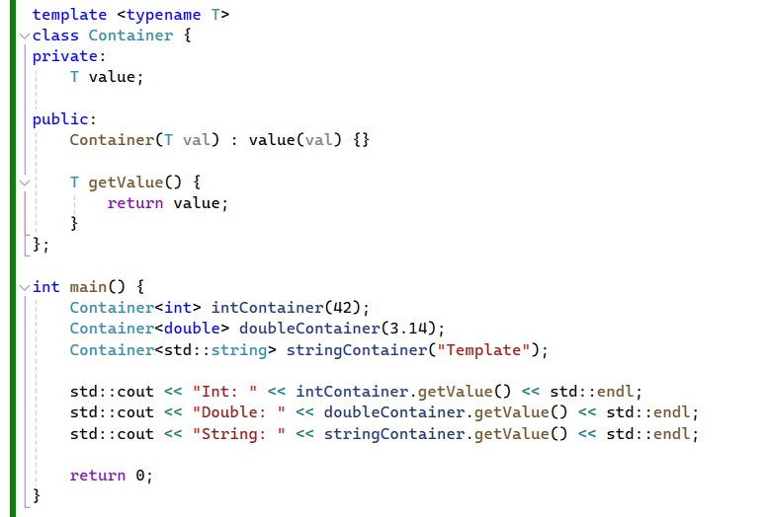

**Summary**

Polymorphism in C++ can be achieved through several mechanisms, including:

1. **Compile-time Polymorphism (Static Polymorphism)**:
   * Method Overloading
   * Operator Overloading
2. **Runtime Polymorphism (Dynamic Polymorphism)**:
   * Method Overriding (using virtual functions)
   * Interfaces (Abstract Classes)
3. **Generic Programming (Templates)**:
   * Function Templates
   * Class Templates

Additional mechanisms and advanced techniques that complement these include:

* Type Erasure (**std::any**, **std::function**)
* Virtual Inheritance
* CRTP (Curiously Recurring Template Pattern)
* Dynamic Typing with **std::variant** and **boost::any**

Each of these approaches has its own use cases and advantages. By understanding and appropriately applying these techniques, you can leverage polymorphism to create flexible, reusable, and maintainable code.

1. **Declaration of Virtual Functions:**

In our base class **`Account`,** we declare certain functions as virtual, such as **`accumulateinterest`** and **`getinterestrate`.** These functions are marked as virtual because they are intended to be overridden by derived classes.

1. **Compilation Process:**

When the compiler compiles the **`Account`** class, it generates a virtual table (vtable). This table contains pointers to the virtual functions declared in the class.

1. **Virtual Pointer (vptr):**

The compiler adds **a special member variable** called the virtual pointer (vptr) to each class that contains virtual functions. This vptr points to the virtual table corresponding to the class.

1. **Inheritance and Virtual Tables:**

When we inherit from the **`Account`** class to create a derived class like **`savingsaccount`,** the compiler generates a separate virtual table for the derived class. This virtual table contains pointers to the overridden virtual functions, as well as any inherited virtual functions from the base class.

1. **Address Resolution:**

When an object of a derived class is created, the virtual pointer (vptr) in that object is initialized to point to the virtual table of the derived class. This initialization typically occurs in the constructors of the classes involved.

1. **Dynamic Dispatch**

When a virtual function is called through a base class pointer or reference, the actual function to be executed is determined at runtime based on the dynamic type of the object. The vptr ensures that the correct function from the correct virtual table is called.

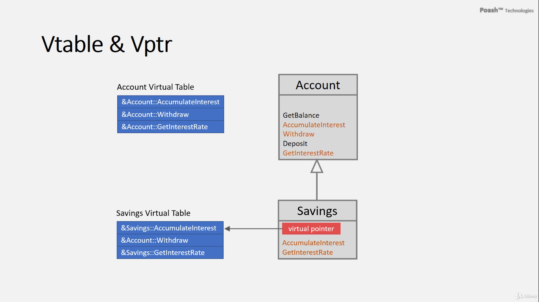

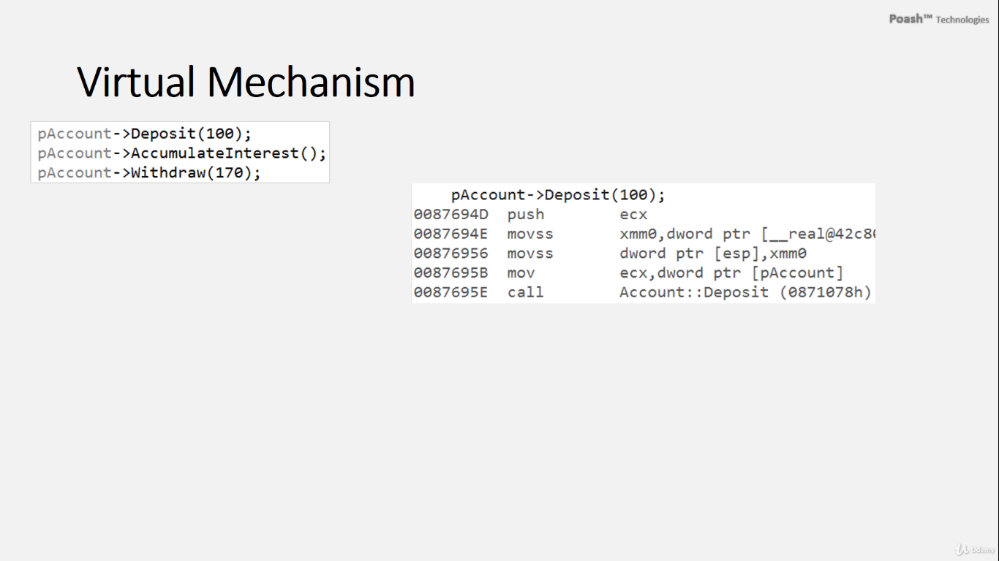

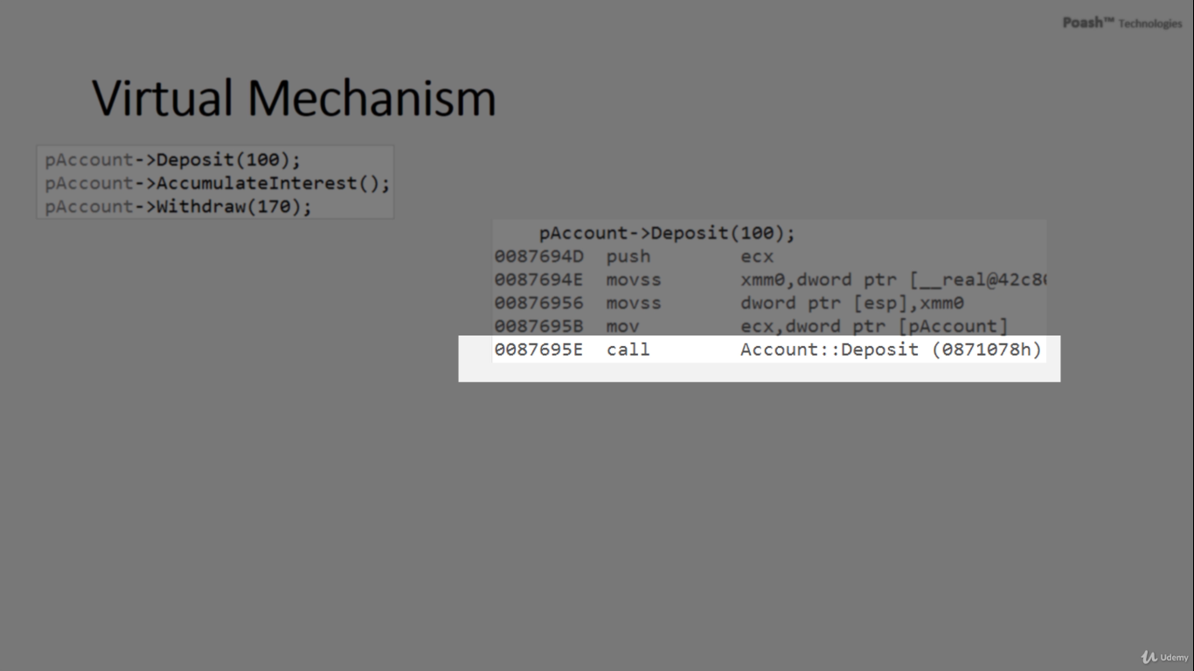

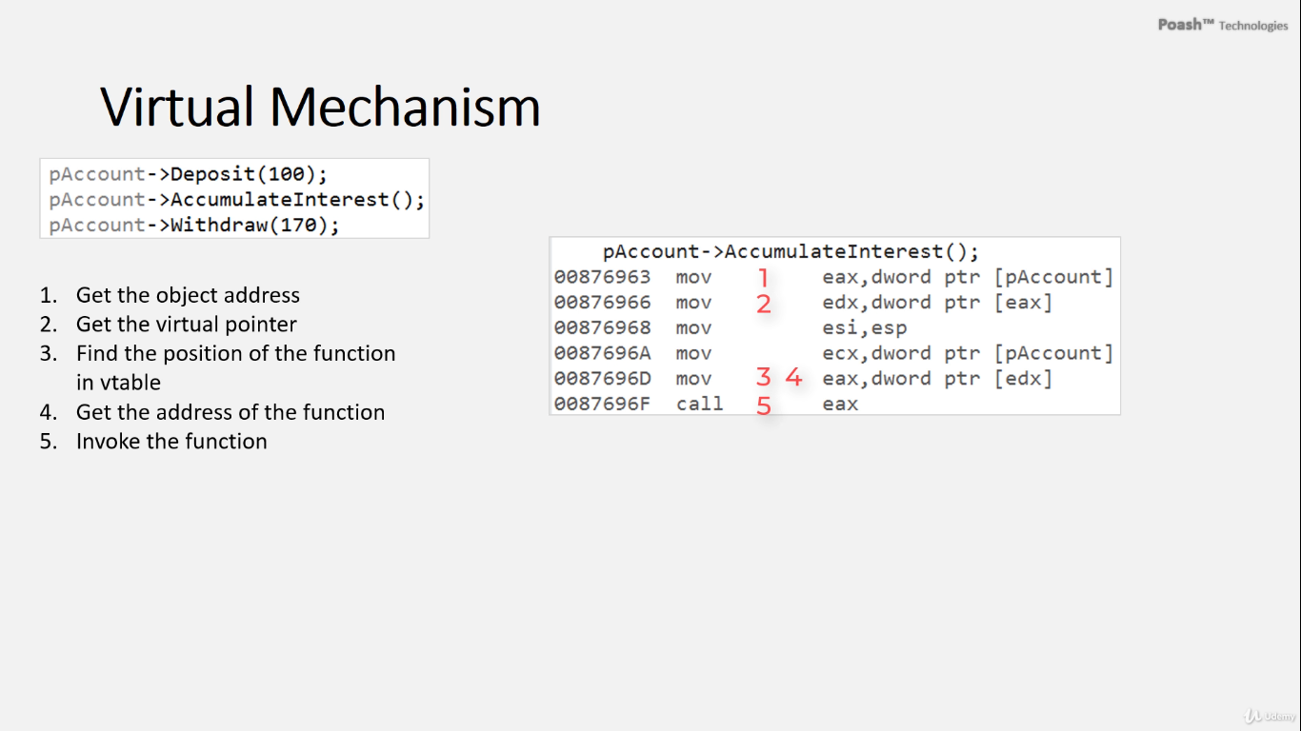

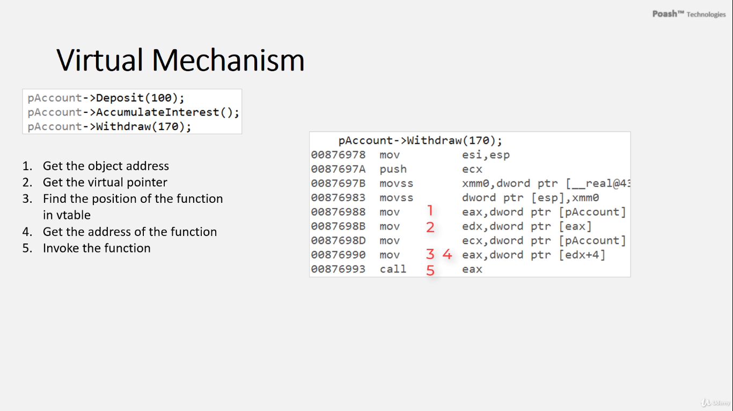

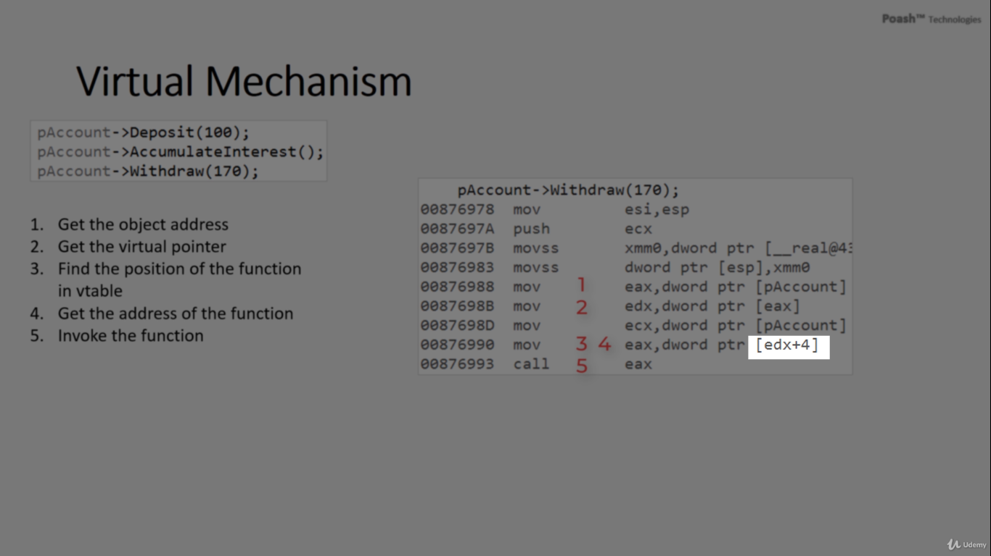

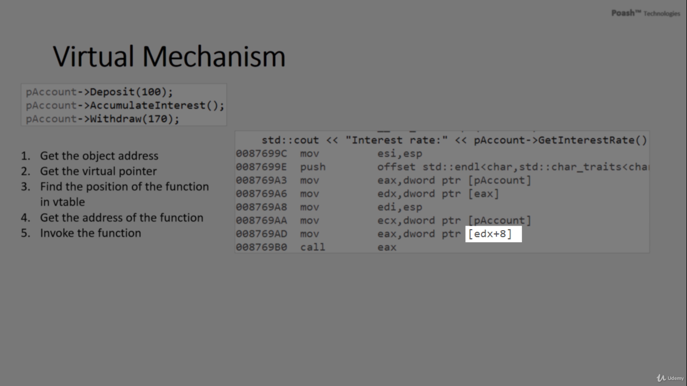

1. **Non-Virtual Function Invocation (e.g., deposit):**
   * When invoking a non-virtual function like **deposit**, the compiler determines which function to call at compile time. As a result, it directly inserts the call to the **deposit** function of the **Account** class.
2. **Virtual Function Invocation (e.g., accumulateinterest, Withdraw, getinterestrate):**
   * For virtual functions such as **accumulateinterest**, **Withdraw**, and **getinterestrate**, additional steps are involved because the compiler needs to resolve the function at runtime.
   * The compiler initially identifies the object pointed to by the **Account** pointer and stores its address.
   * It then retrieves the virtual pointer (vptr) from the object's memory and stores it in a register.
   * Next, the **compiler calculates the position** of the function in the virtual table by applying an **offset to the address stored in the virtual pointer**.
   * Since each function pointer in the virtual table **occupies** four bytes on a 32-bit platform, the offset is computed accordingly.
   * Finally, using the offset, the compiler fetches the address of the function from the virtual table and invokes it.
   * For instance:
     + If **accumulateinterest** occupies the first slot in the virtual table, the offset would be **zero**.
     + If **Withdraw** occupies the second slot, the offset would be **four bytes**.
     + If **getinterestrate** occupies the third slot, the offset would be **eight bytes**.
   * This process ensures that the correct function is invoked at runtime, providing the desired polymorphic behavior.
3. **Explanation of Offsets:**
   * The offset indicates the position of the function in the virtual table. Since each address in the virtual table occupies four bytes, the compiler increments the offset by four bytes for each subsequent function. For example, an offset of eight bytes signifies that the function occupies the third slot in the virtual table.

Understanding these mechanisms clarifies how the compiler generates code to invoke virtual functions and ensures correct behavior at runtime, facilitating polymorphism within the program.

**How dynamic polymorphism works in C++ with virtual functions and inheritance.**

1. **Virtual Functions and Base Class Pointer:**
   * In C++, when a function in a base class is declared as virtual, it signifies that it can be overridden by derived classes.
   * When you have a pointer of the base class type pointing to an object of a derived class, and you invoke a virtual function through that pointer, the function called is **determined by the actual object type, not the pointer type.**
2. **Virtual Table (Vtable):**
   * Each class with at least one virtual function has an associated virtual table, also known as a vtable.
   * **The virtual table is an array of function pointers**. Each entry in the vtable corresponds to a virtual function in the class.
   * The compiler generates the vtable for each class with virtual functions during compilation.
3. **Virtual Pointer (Vptr):**
   * Every object of a class with virtual functions contains **a hidden member known as the virtual pointer (vptr).**
   * **The vptr points to the virtual table** of the corresponding class. It allows the program to determine the correct function to call at runtime.
4. **Dynamic Polymorphism:**
   * When you call a virtual function through a base class pointer, the program looks up the function in the vtable associated with the actual object type.
   * If the function is overridden in the derived class, the vtable entry for that function points to the overridden implementation in the derived class.
   * This lookup ensures that the correct function is called based on the actual object type, even if the pointer type is that of the base class.
   * As a result, dynamic polymorphism allows different derived classes to provide their implementations of virtual functions, and the appropriate implementation is invoked based on the actual object type at runtime.

In summary, the virtual table and virtual pointer mechanisms enable dynamic polymorphism in C++. The virtual table contains function pointers for virtual functions, and the virtual pointer in each object points to the appropriate virtual table. This setup allows the program to determine the correct function to call at runtime, based on the actual object type, leading to dynamic behavior and polymorphism.  
When there are multiple derived classes inheriting from a common base class and each of them overrides the

# Determination of which overridden function to invoke at runtime

same virtual function, the determination of which overridden function to invoke at runtime depends on the type of the object that the base class pointer is pointing to.

Consider the following scenario:

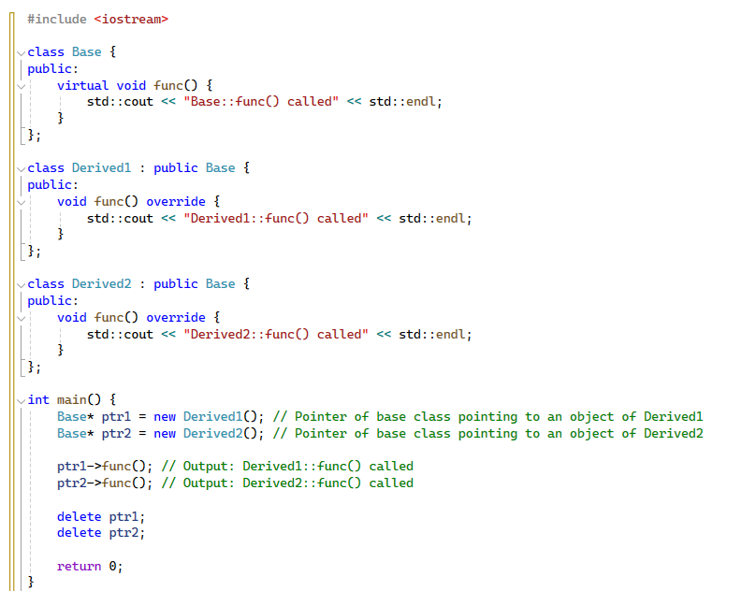

**In this example:**

* We have a base class **Base** with a virtual function **func()**.
* Two derived classes **Derived1** and **Derived2** override the **func()** function.
* In the **main()** function, we create two pointers of type **Base\***, pointing to objects of **Derived1** and **Derived2**.
* When we call the **func()** function through these pointers, the program dynamically resolves which version of the function to call based on the actual type of the object being pointed to.
* So, even though both pointers are of type **Base\***, the overridden function corresponding to the actual derived class object is invoked at runtime.

In summary, when there are multiple derived classes with overridden functions, the determination of which overridden function to call is based on the runtime type of the object being pointed to by the base class pointer, allowing for dynamic dispatch and polymorphic behavior.

* If you have a pointer of the parent class type and you assign it to an object of one of the child classes, and then you call a virtual function through that pointer, **the function invoked will be determined by the dynamic type of the object the pointer is pointing to**. This is known as runtime polymorphism or dynamic dispatch.

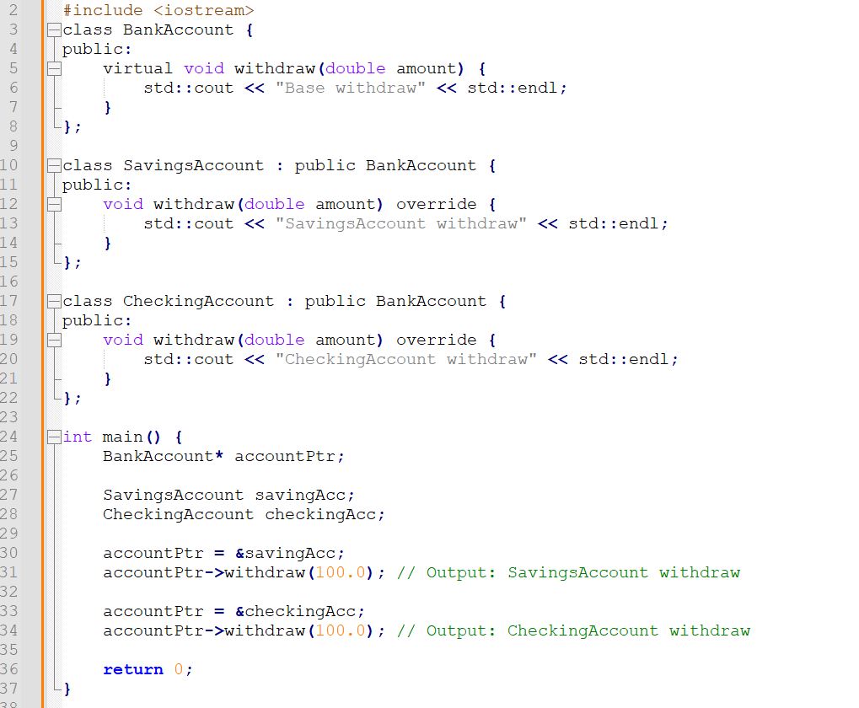

* In this example, **`accountptr`** is a pointer of type **`bankaccount`,** but it is assigned addresses of objects of both **`savingsaccount`** and **`checkingaccount`**. When `withdraw()` is called through `accountptr`, the actual **function executed depends on the dynamic type of the object the pointer is currently pointing to.**
* So, if **`accountptr`** points to a **`savingsaccount`** object, invoking **`withdraw()`** will execute the **`withdraw()`** function from the **`savingsaccount`** class.
* Similarly, if **`accountptr`** points to a **`checkingaccount`** object, invoking `withdraw()` will execute the **`withdraw()`** function from the **`checkingaccount`** class.
* When you have a pointer of the parent class type and you assign it to objects of different child classes, **the function invoked through that pointer depends on the actual type of the object it points to at runtime.** This behavior is determined by the dynamic type of the object, allowing for polymorphic behavior where the appropriate function implementation **is selected based on the actual object's type at runtime.**

If you have an object of the parent class type, without using pointers or references, you won't achieve polymorphic behavior because C++ uses static binding for non-pointer and non-reference objects. This means that the function called will be determined at compile time-based on the static (declared) type of the object.



In this case, the **`withdraw()`** function associated with the **`bankaccount`** class will be called because the object is of type **`bankaccount`** **(Base Class)** and there's no dynamic dispatch involved.

However, using pointers or references to objects of the parent class type allows you **to achieve dynamic dispatch,** which is essential for polymorphic behavior in C++. This way, the appropriate function associated with the dynamic (actual) type of the object is called at runtime, regardless of the static type of the pointer or reference.

# Adding the `virtual` keyword to the destructor of a base class uses polymorphism with derived classes.

1. **Proper Cleanup in Derived Classes:**

When you delete an object of a derived class through a pointer to the base class, and the base class destructor is not virtual, only the **base class destructor will be called**. This can **lead to improper cleanup of resources allocated in the derived class**, potentially causing memory leaks or undefined behavior.

1. **Ensure Proper Destructor Invocation:**

Making the base class destructor virtual ensures that when you delete an object of a derived class through a pointer to the base class, **both the base class destructor and the derived class destructor are invoked.** This allows for proper cleanup of resources in both the base and derived classes.

1. **Polymorphic Behavior:**

Including a virtual destructor in the base class enables polymorphic behavior when dealing with objects through base class pointers or references. It ensures that the appropriate destructor for the actual dynamic type of the object is invoked, rather than just the destructor of the base class.

1. **Avoid Memory Leaks:**

Without a virtual destructor, if you delete an object of a derived class through a base class pointer, **only the base class destructor is called.** This could leave behind resources allocated by the derived class, leading to memory leaks.

In summary, adding the `virtual` keyword to the destructor of the base class is crucial for proper cleanup and polymorphic behavior, especially when dealing with inheritance and polymorphism in C++.

# Final keyword

Using the **final** keyword in C++ allows you to enforce certain restrictions on classes and member functions within your codebase. Here's a breakdown of its usage:

1. **Final Classes**: When a class is marked as **final**, it serves as a declaration that it cannot be used as a base class for inheritance. In other words, no other class can derive from it. This restriction ensures that the class's implementation and interface remain unchanged and cannot be extended further.
2. **Final Methods**: Similarly, when a method within a class is marked as **final**, it implies that it cannot be overridden by any derived class. This restriction is particularly useful when you want to enforce specific behavior or ensure that certain critical methods retain their functionality across all derived classes.
3. **Final Virtual Functions**: In the context of virtual functions, marking a function as **final** in a base class means that it cannot be overridden in any derived class. This is useful when you want to enforce a specific implementation of a virtual function throughout the inheritance hierarchy, ensuring that certain behaviors remain consistent across all derived classes.
4. **Final Classes**:

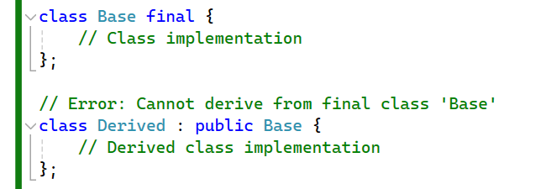

1. **Final Methods**:

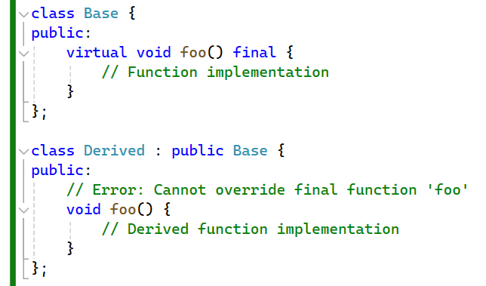

1. **Final Virtual Functions**:

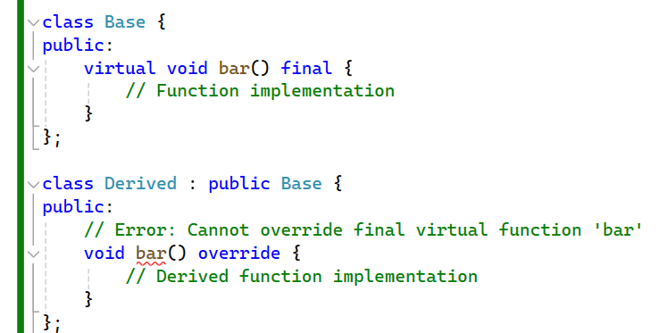Top of Form

# Override keyword

* Is used to explicitly declare that a member function of a derived class is intended to override a virtual function in a base class. It **enhances code readability and helps catch errors during compilation** by ensuring that the function signature in the derived class matches the signature of the virtual function in the base class.

1. **Inheritance and Overriding:** When you inherit from a base class and intend to override one of its virtual functions, you can use **the `override**` keyword in the derived class.
2. **Error Prevention:** If you **use `override`** but the function signature in the derived class does not match any virtual function in the base class, or if there is no virtual function in the base class that it overrides, the compiler generates an error. This helps catch mistakes at compile time.

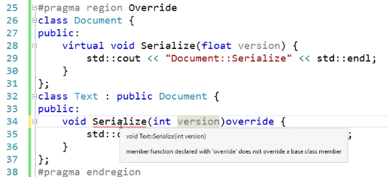

* In this example, the **`Serialize()`** function in the **`Derived`** class is marked as `override`, but the corresponding virtual function named **` Serialize ()`** in the base class has a different signature int instead of float **`Base`.** Hence, the compiler generates an error.
* Also, **Serialize()** must be a virtual function in First Place

Using the **`override`** keyword is considered good practice in C++ when you're dealing with virtual functions and inheritance. It makes your code clearer and helps prevent errors related to function overriding.

If we specify a member function with a final keyword that function can not be overridden

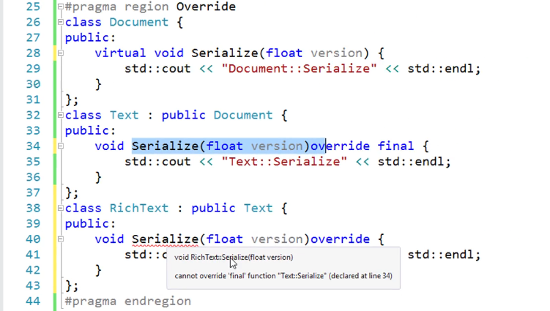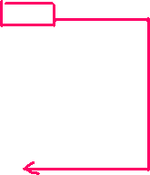

* You can override a virtual member function from a parent class in multiple child classes. **There is no restriction on the number of child classes that can override the virtual function**. Each child class can independently override the virtual function as needed, providing its implementation.

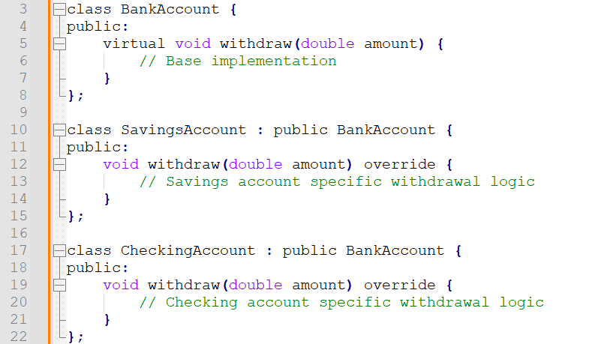

# The object slicing

* When you assign a child class object to a base class object, the object slicing phenomenon occurs if you do it directly:



* In this case, only the **base class part of the child object is copied into the base class object**, and any additional data or behavior specific to the child class is **lost**.
* However, if you use pointers or references, you can maintain polymorphic behavior and avoid object slicing:



* With pointers or references, you're not converting the object itself; you're just pointing or referring to it. So, you retain the actual dynamic type of the object and can still invoke polymorphic behavior through virtual functions.

**Here's an example to illustrate:**

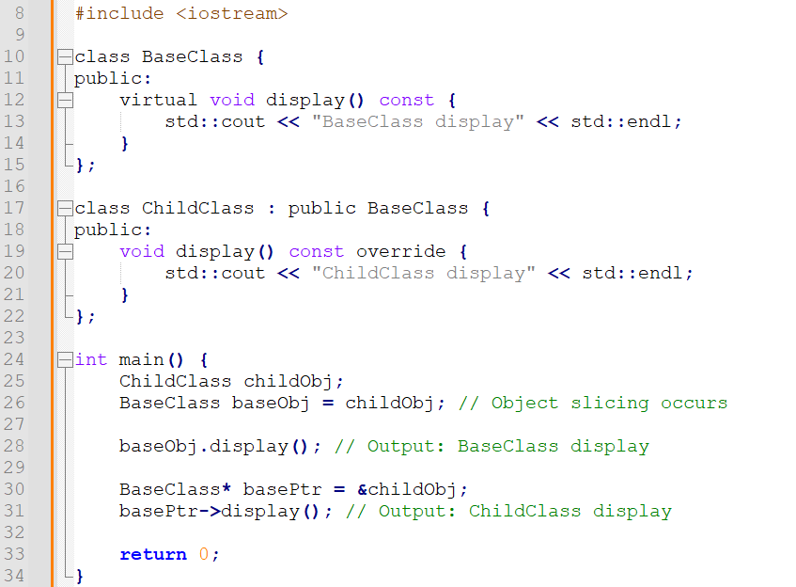

* In this example, **`baseobj`** **slices** the **`childobj`,** so calling **`display()`** on **`baseobj`** invokes the **`display()`** function from `baseclass`.
* However, **`baseptr`** maintains polymorphic behavior, so calling **`display()`** through **`baseptr`** invokes the **`display()`** function from **`childclass`.**

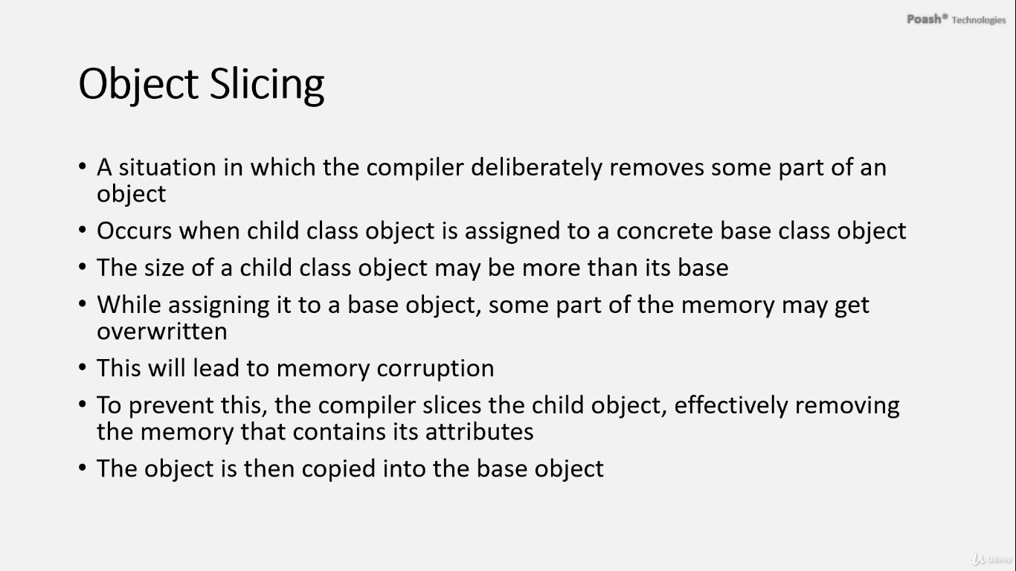

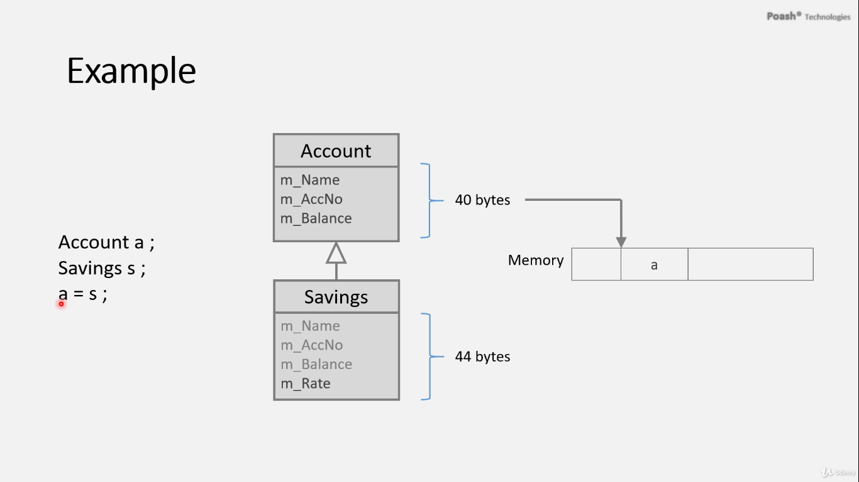

A child object is obviously larger in size than the parent object because it contains attributes inherited from their parent class and its own attributes.

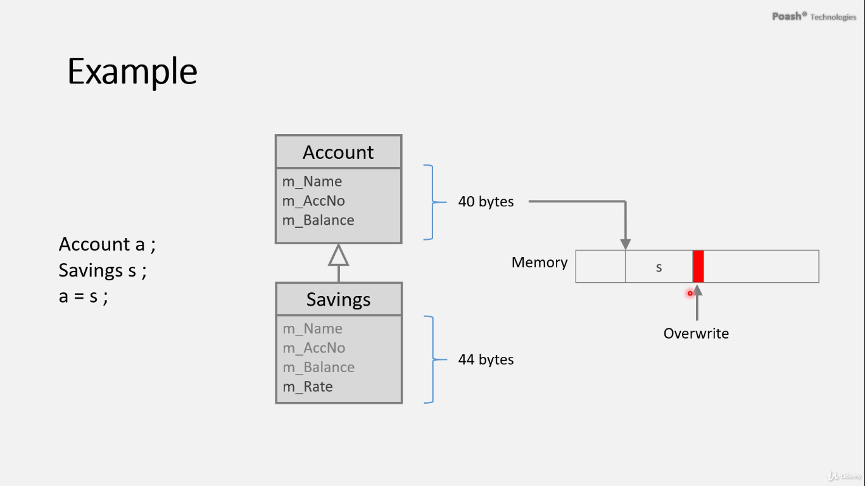

The compiler will perform object slicing to prevent any corruption in the memory.

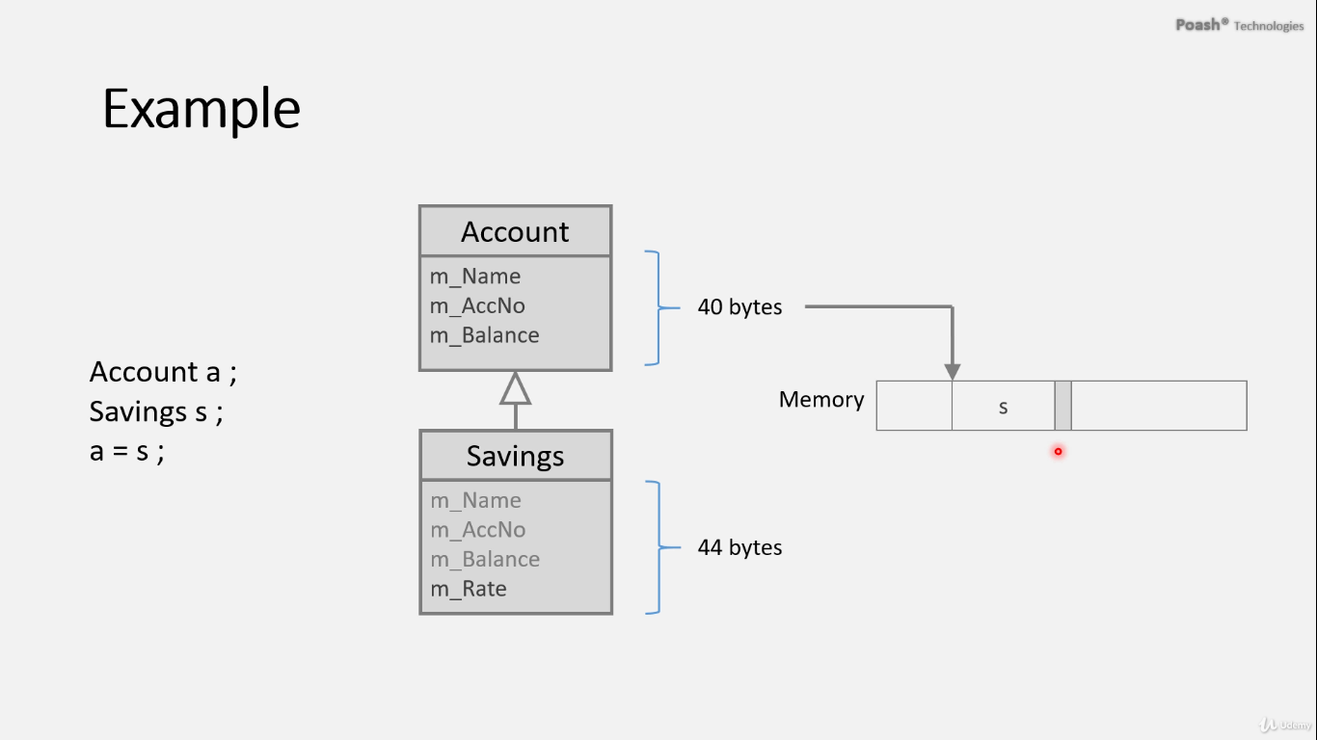

# Typeid operator:

1. **Purpose:**

* The **typeid** operator in C++ serves the purpose of obtaining information about the type of an object at runtime.

1. **Usage:**

* **typeid** can be utilized with either an object or a pointer to an object.
* When applied with an object, it furnishes information about the dynamic type of that particular object.
* In the case of a pointer, it is essential to dereference the pointer to acquire the type of the object it refers to.

1. **Polymorphic Types:**

* For polymorphic types, which are types containing at least one virtual function, **typeid** operates at runtime.
* It discerns the dynamic type of the object, enabling decisions or actions to be based on the actual type of the object during program execution.

1. **Non-Polymorphic Types:**

* **typeid** behaves differently when used with non-polymorphic types, gathering type information at compile time.
* Type information provided by **typeid** in such cases is based on the static type of the object or expression.

1. **Comparison Operators:**

* Comparison operators such as **==**, **<**, **>**, etc., can be employed alongside **typeid** to compare types.
* This facilitates decision-making processes based on the type of object that the pointer references.

1. **Precautions:**

* To ensure proper functionality with polymorphic types, it is imperative for the base class to contain at least one virtual function.
* This prerequisite guarantees that the dynamic type of the object is accurately identified at runtime, ensuring reliable behavior when utilizing **typeid**.

**7. Example:**

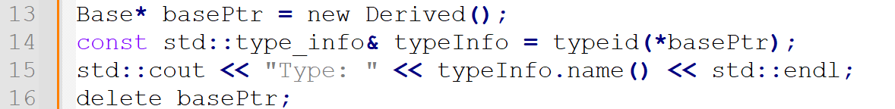

# Abstract classes and pure virtual functions

‎1.‎ **Document Hierarchy:**

* Our document hierarchy originates with a base class named **Document**, which includes a virtual function **serialize()**.
* Child classes within this hierarchy have the flexibility to override **serialize()**, tailoring the serialization process to suit specific document types, such as text or XML.

‎2.‎ **Challenges with Inheritance:**

* Let's consider a scenario where we have an **XML** class derived from **Document**, but it fails to override **serialize()**.
* If a client attempts to serialize an **XML** object using a **Document** pointer, the default **serialize()** from the base class is invoked, resulting in inadequate handling of XML data serialization.

‎3.‎ **Addressing Challenges:**

* To overcome this challenge, we elevate **serialize()** to a pure virtual function in the base class by assigning it a value of zero.
* This transformation turns **Document** into an abstract class, requiring child classes to implement **serialize()**.
* Any attempt to instantiate an **XML** object without implementing **serialize()** triggers a compilation error, ensuring adherence to implementation requirements.

‎4.‎ **Ensuring Correct Behavior:**

* By providing a placeholder implementation of **serialize()** in the **XML** class, we ensure correct invocation and proper handling of XML data serialization.
* Clients invoking **serialize()** on **Document** pointers can trust in the implementations provided by child classes, fostering accurate and predictable behavior.

‎5.‎ **Key Points about Abstract Classes and Pure Virtual Functions:**

* Abstract classes feature at least one pure virtual function and may include additional members defining common behavior.
* They cannot be directly instantiated but are utilized via pointers or references.
* Pure virtual functions establish a contractual obligation, compelling derived classes to furnish their implementations.
* Abstract classes act as architectural blueprints, outlining interfaces and defining behavior without specifying implementation specifics.
* Pure virtual functions, designated with the **= 0** specifier, cannot be invoked directly and must be overridden by derived classes; failure to do so results in the derived class becoming abstract.

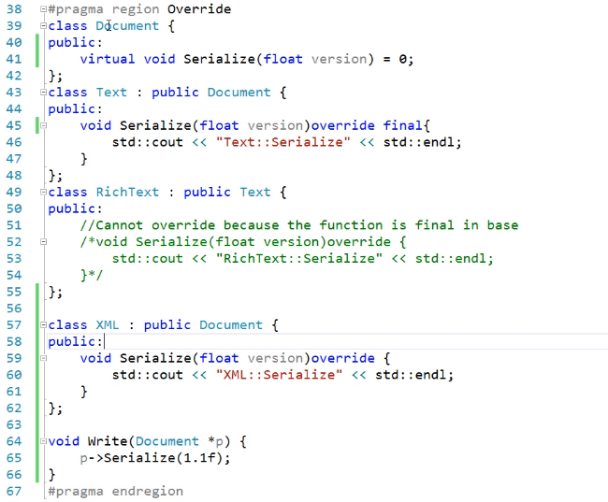

# Summary of Abstraction

**Abstraction** is a core principle in OOP that involves simplifying complex systems by modeling classes based on the essential characteristics and behaviors they represent, while hiding the unnecessary details. This allows developers to manage complexity and focus on high-level interactions.

**Key Points of Abstraction:**

1. **Defining Interfaces**:
   * Use abstract classes and interfaces (in C++, interfaces are implemented via abstract classes with only pure virtual functions) to define a common interface for a group of related classes.
   * An abstract class contains at least one pure virtual function and cannot be instantiated.
   * Example:

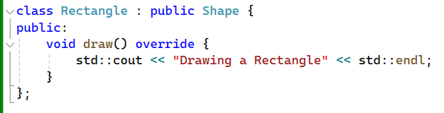

1. **Hiding Implementation Details**:
   * Implementation details **are hidden in the base (abstract**) class, and the specific implementation is provided by the derived (concrete) classes.
   * This separation allows users of the base class to interact with objects without needing to know the details of their implementations.
   * Example:

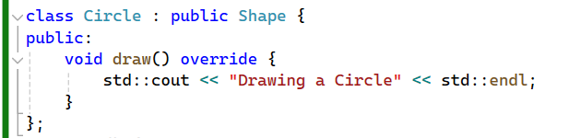

1. **Encapsulation**:
   * Abstraction works **hand-in-hand with encapsulation** by **hiding the internal state and requiring all interaction** to be performed through an object’s methods.
   * This ensures that the internal state is protected and can be changed only in a controlled manner.
   * Example:

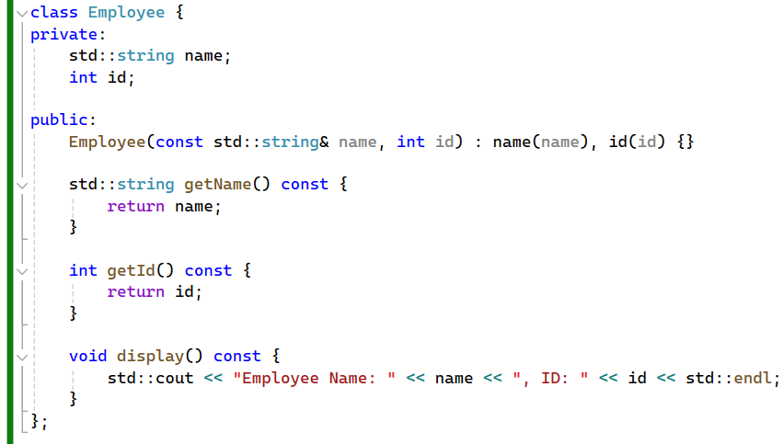

1. **Polymorphism**:
   * Abstraction supports polymorphism, allowing different classes to be treated uniformly through base class pointers or references.
   * This enables dynamic binding, where the appropriate method implementation is called at runtime based on the actual object type.
   * Example:

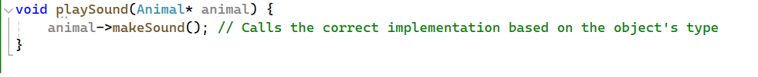

1. **Promoting Reusability and Flexibility**:
   * By defining abstract interfaces and leaving the details to derived classes, you create a flexible code structure that is easy to extend and modify.
   * New concrete classes can be added without altering the existing code that interacts with the abstract base class.
   * Example:

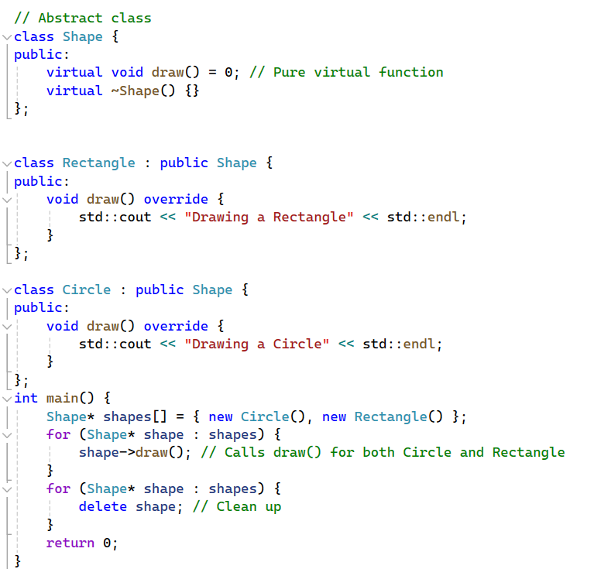

**Practical Example**

Let's summarize with a comprehensive example that combines these concepts:

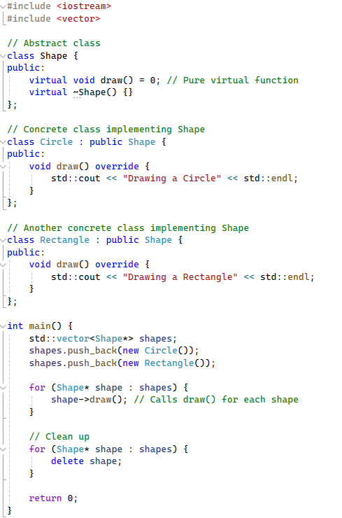

In this example:

* **Shape** is an abstract class with a pure virtual function **draw()**.
* **Circle** and **Rectangle** are concrete classes that provide specific implementations of **draw()**.
* In **main()**, we use polymorphism to store different shapes in a single vector and call **draw()** on each one, demonstrating abstraction and dynamic binding.

By abstracting common features into abstract classes and interfaces, you achieve a clean separation of what an object does (its interface) from how it does it (its implementation), leading to more modular, maintainable, and extensible code.

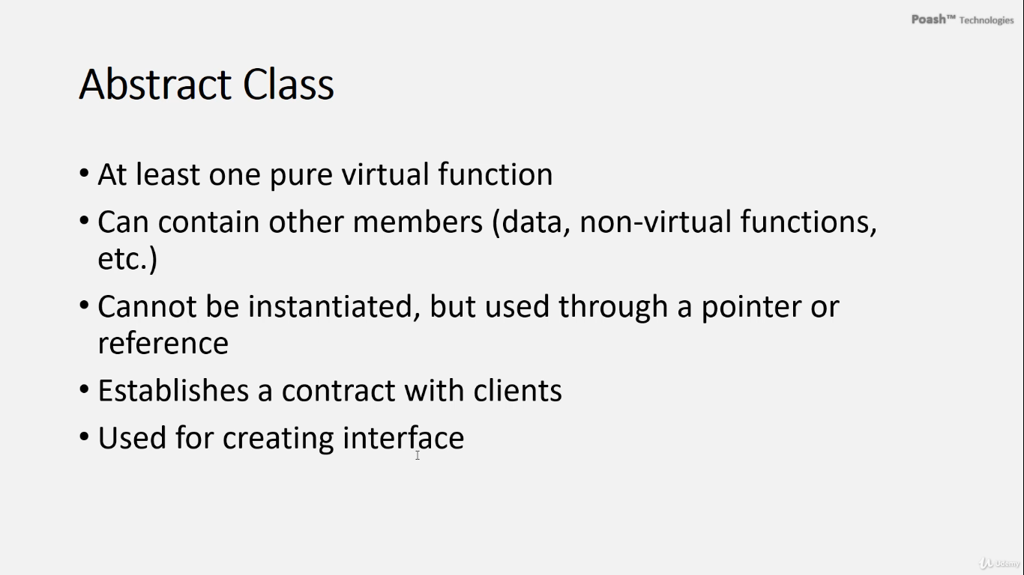

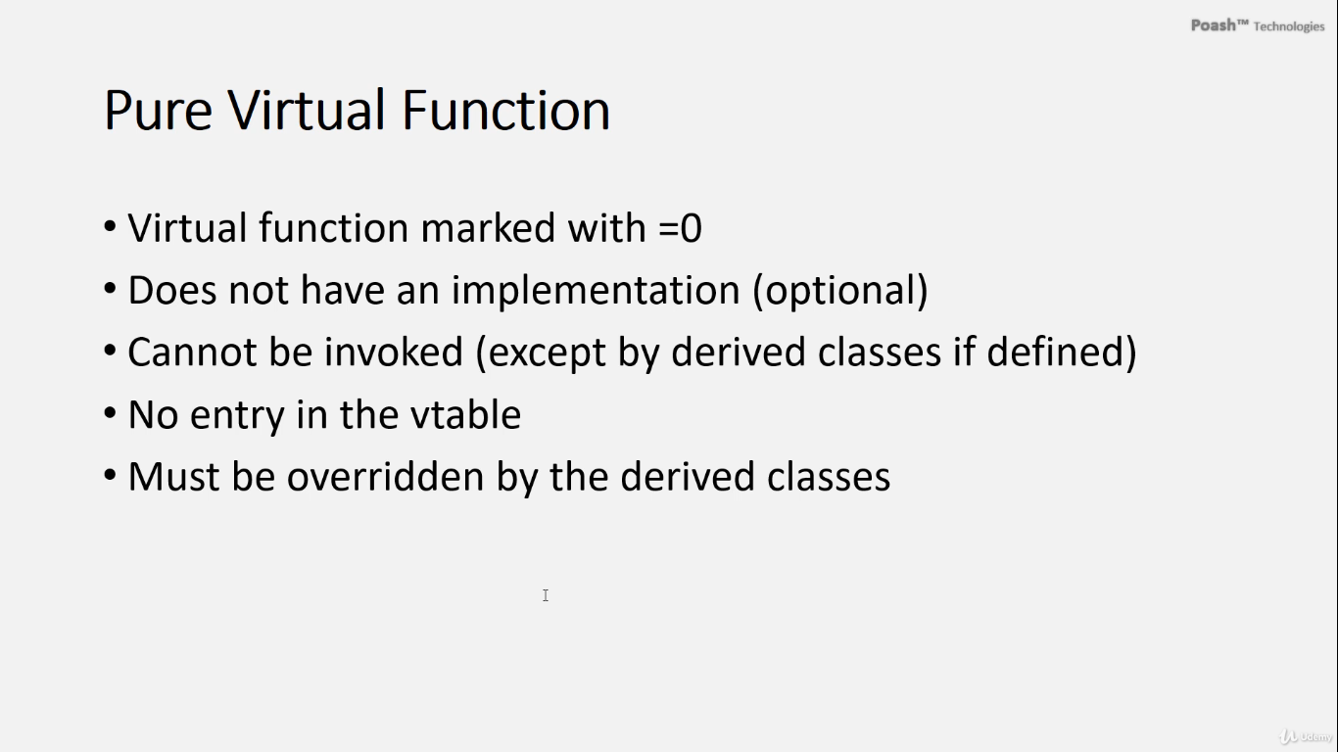

# Multiple Inheritance

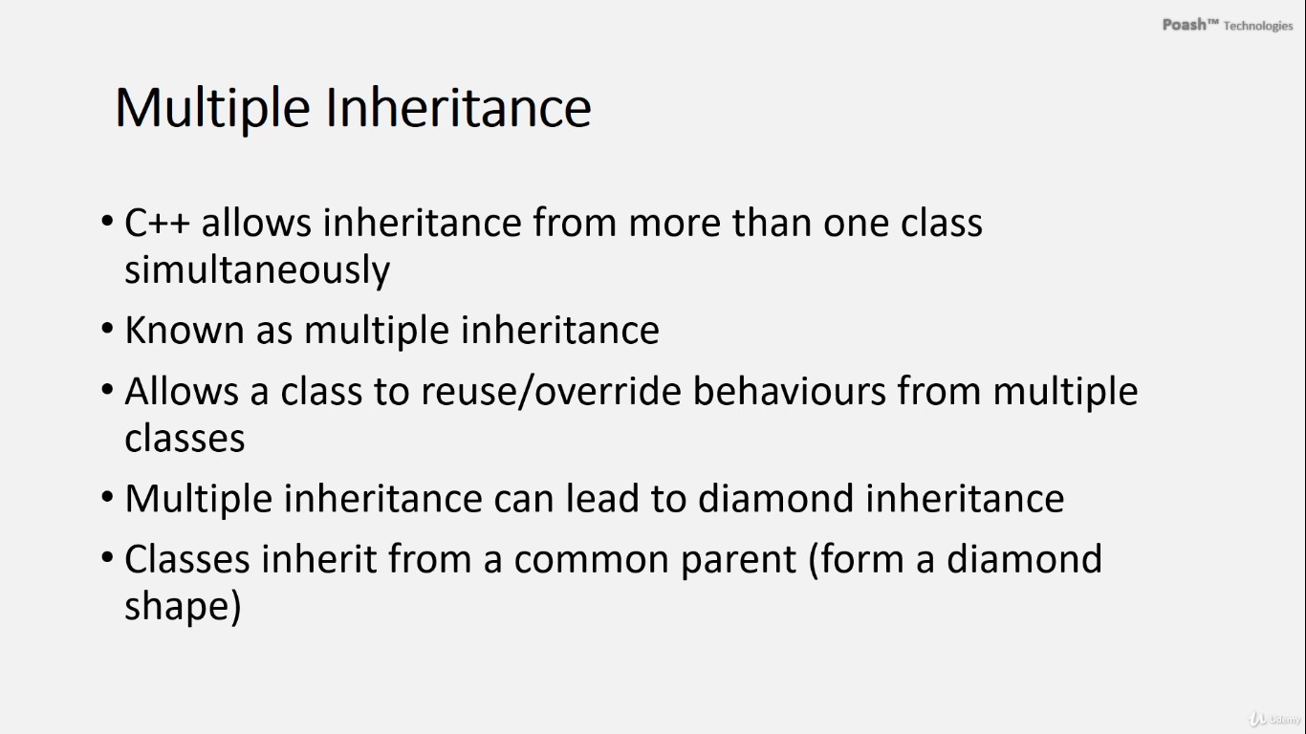

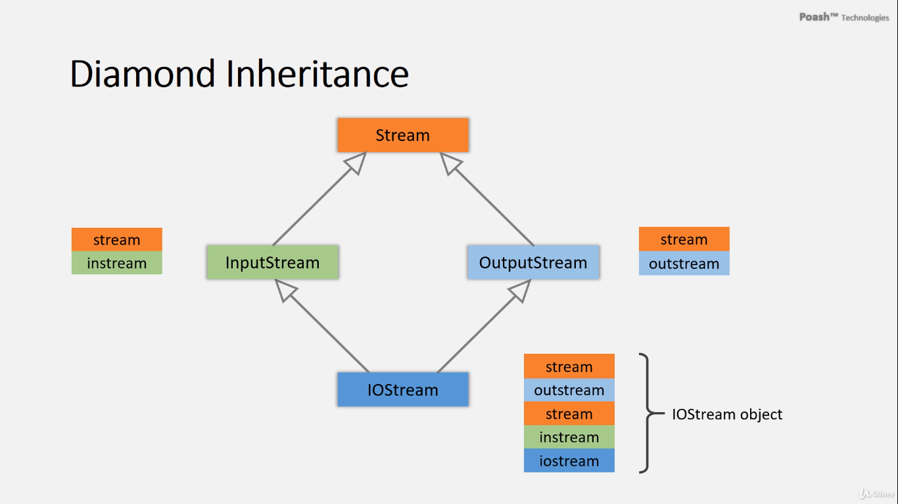

In C++, a class can inherit from more than one class simultaneously, a concept known as multiple inheritance. This feature is particularly useful when a class needs to incorporate behaviors from different classes.

However, multiple inheritance can lead to a scenario known as diamond inheritance, where a derived class inherits from two classes that themselves inherit from a common base class. This results in an inheritance hierarchy that resembles a diamond shape in diagrams.

For instance, consider a Stream class representing common operations for all streams. The OutputStream class inherits from Stream to provide write capabilities, while the InputStream class inherits from Stream to provide read capabilities.

If we want a class to support both reading and writing, we can inherit from both InputStream and OutputStream, creating a diamond inheritance hierarchy.

However, diamond inheritance can introduce issues such as ambiguity or redundant data. For example, in the case of an IOStream class inheriting from both InputStream and OutputStream, the IOStream object would contain instances of both InputStream and OutputStream, leading to two instances of the Stream class. This redundancy can cause problems in the program.

In C++, this issue can be resolved using virtual inheritance. By declaring the inheritance from Stream as virtual in both InputStream and OutputStream, we ensure that only one instance of Stream is shared among them, preventing redundancy and ambiguity.

In C++, we can represent a Stream class that handles common operations for file streams, including a constructor, destructor, and a getFileName() function.

The OutputStream and InputStream classes inherit from Stream and provide functionality for writing to and reading from files, respectively. They also include overloaded stream insertion and extraction operators for convenience.

The IOStream class inherits from both InputStream and OutputStream, forming a diamond inheritance hierarchy.

In the main() function, an instance of IOStream is created with a specified filename. The program attempts to read data from the IOStream, write data to it, and retrieve its filename.

**Problems:**

1. **Redundant Data**: Due to diamond inheritance, the IOStream object contains two instances of the Stream class, which can lead to redundant file-handling operations.
2. **Ambiguity**: Invoking member functions inherited from Stream, such as getFileName(), results in an error due to ambiguity caused by multiple instances of the Stream class.

**Solution:**

To resolve these issues, we use virtual inheritance for InputStream and OutputStream. This ensures that there is only one instance of the Stream class in the IOStream object, thus mitigating redundancy and ambiguity errors.

Here's an example in C++:

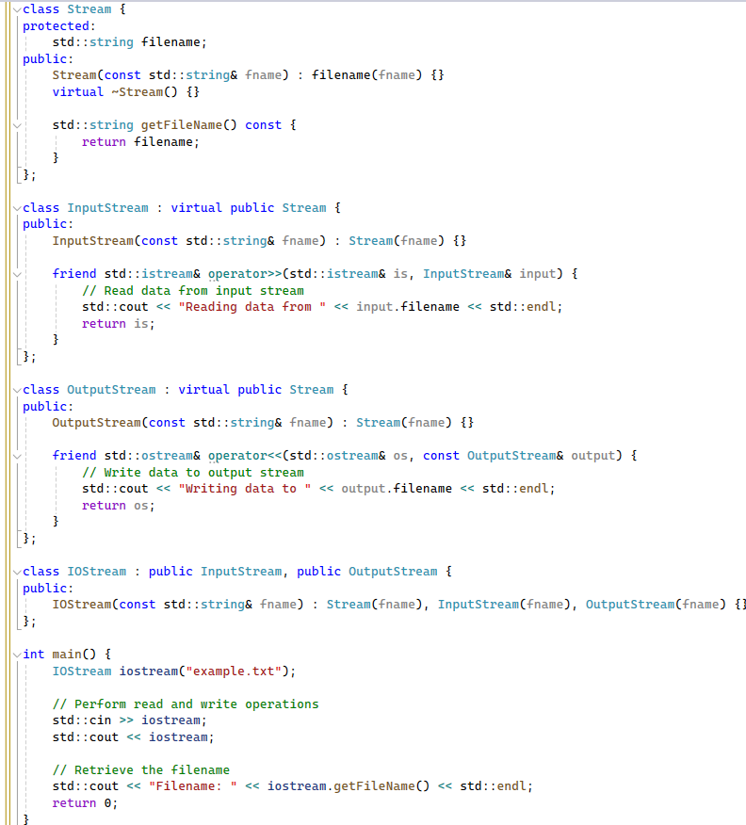

In C++, when using virtual inheritance, the base class's constructor must be explicitly called by the most derived class. This ensures that the base class is properly initialized only once. Here’s a detailed explanation of why we call Stream(fname), InputStream(fname), and OutputStream(fname) in the IOStream constructor:

1. **Virtual Inheritance**:

* When a class inherits from another class virtually, it means that the base class (in this case, Stream) will be shared among all derived classes. The virtual base class is only constructed once, no matter how many times it appears in the inheritance hierarchy.

1. **Constructor Initialization**:

* The most derived class (IOStream) is responsible for initializing the virtual base class (Stream). This ensures that the Stream class is constructed only once.

1. **Calling Base Class Constructors**:

* When constructing an IOStream object, we need to initialize the Stream class with the filename. This is done by explicitly calling Stream(fname) in the IOStream initializer list.
* Additionally, we also need to call the constructors of the intermediate classes (InputStream and OutputStream). This is done to ensure any specific initialization in those classes is also performed correctly.

**Explanation:**

1. **Virtual Inheritance**: The InputStream and OutputStream classes inherit from Stream using the virtual keyword, ensuring that only one instance of Stream is present in IOStream.
2. **Initialization**: In the IOStream constructor, the Stream class is initialized directly to avoid redundant initialization.

**When creating an IOStream object, the constructors are called in the following order:**

1. Stream(fname):

* Initializes the Stream base class with the filename.

1. InputStream(fname):

* Calls the Stream(fname) constructor due to virtual inheritance.

1. OutputStream(fname):

* Calls the Stream(fname) constructor due to virtual inheritance.

1. IOStream(fname):

* Calls the constructors of Stream, InputStream, and OutputStream.

By explicitly calling these constructors, we ensure that:

* The Stream base class is initialized correctly with the filename.
* The InputStream and OutputStream classes are properly constructed.
* There is only one instance of the Stream class due to virtual inheritance, avoiding redundancy and ambiguity.

By using virtual inheritance, we eliminate redundant data and resolve ambiguity issues, ensuring that IOStream functions correctly.

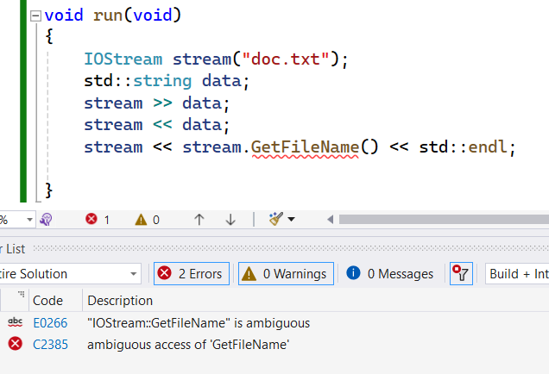

* It gives an error, and ambiguous access to 'getfilename'. There are two instances of the stream object in the iostream object. And when you try to invoke the function that is inherited twice, so the compiler gives an ambiguous access error for this function.
* To resolve this error, We need to ensure that there is only one instance of the stream object in the iostream and we can do this by using virtual inheritance.

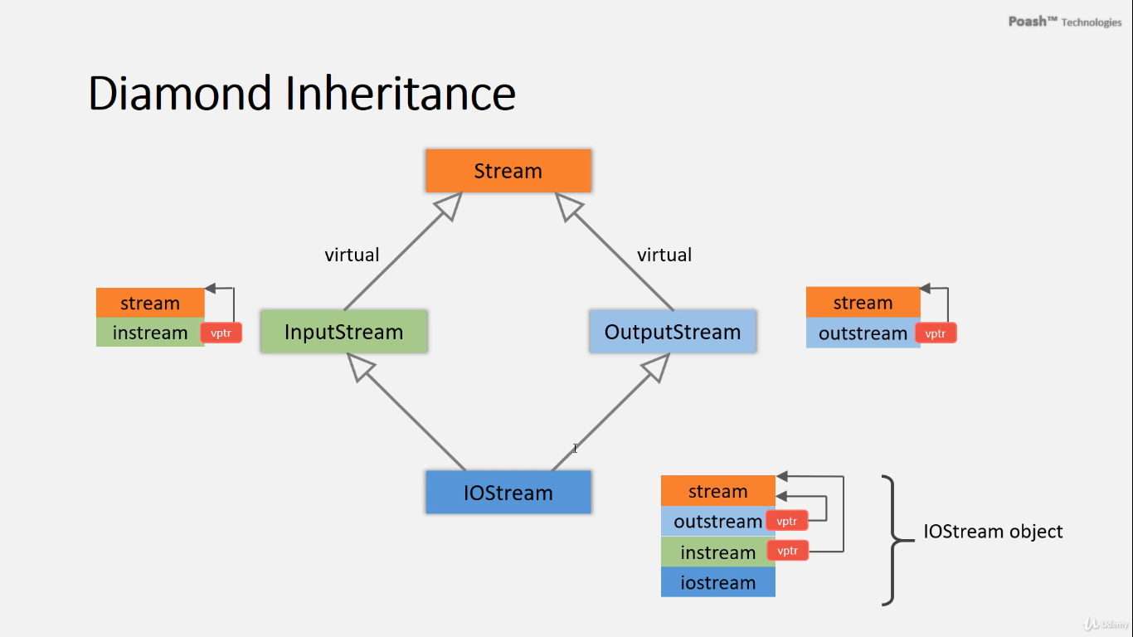

Virtual inheritance is indeed an essential mechanism in C++ for managing complex multiple inheritance scenarios, particularly in cases of diamond inheritance:

**Steps and Key Concepts in Virtual Inheritance**

**1. Virtual Pointers**

* **Virtual Pointer (vptr)**:
  + When using virtual inheritance, the compiler adds a virtual pointer (vptr) to the derived class object.
  + This vptr points to the instance of the virtual base class within the derived class object.

**2. Diamond Inheritance**

* **Diamond Inheritance Structure**:
  + When a class inherits from two base classes that both inherit from a common base class, it forms a diamond shape.
  + For example, if **iostream** inherits from both **outputstream** and **inputstream**, and both of these inherit from **Stream** virtually, it forms a diamond shape.

**3. Single Instance of Virtual Base Class**

* **Shared Instance**:
  + Due to virtual inheritance, only one shared instance of the virtual base class (**Stream**) exists in the most derived class (**iostream**).
  + This ensures consistency and prevents duplication of the base class instance.

**4. Constructor Invocation**

* **Constructor Call Order**:
  + The most derived class (**iostream**) is responsible for initializing the virtual base class (**Stream**).
  + The constructor of **Stream** is called only once, avoiding multiple initializations.

**Practical Example**

Let's illustrate this with a practical example in C++:

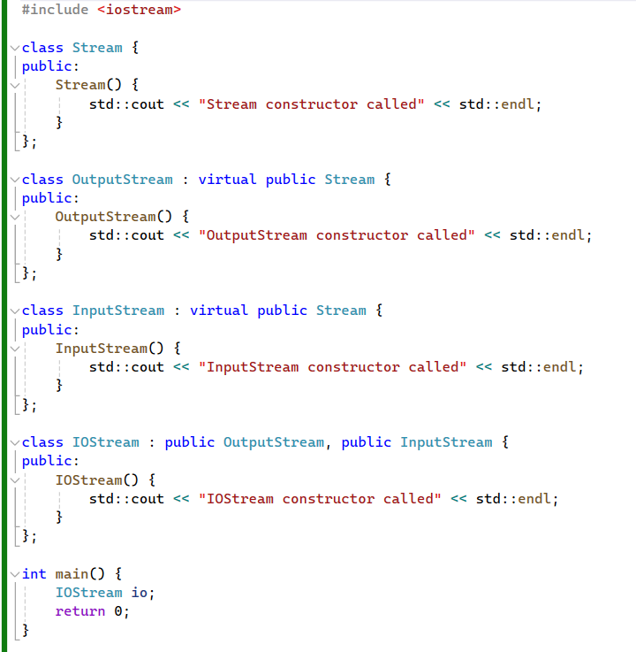

**Explanation of the Output**

1. **Virtual Pointer Initialization**:
   * Each derived class (**OutputStream** and **InputStream**) has a vptr pointing to the single instance of **Stream**.
2. **Diamond Inheritance Handling**:
   * When **IOStream** inherits from both **OutputStream** and **InputStream**, it inherits the **Stream** instance through both paths.
3. **Single Instance of Stream**:
   * Due to virtual inheritance, **IOStream** contains only one instance of **Stream**.
4. **Constructor Invocation Order**:
   * When **IOStream** is instantiated, the constructors are called in the following order:
     + **Stream** constructor (due to virtual inheritance).
     + **OutputStream** constructor.
     + **InputStream** constructor.
     + **IOStream** constructor.

**Output**

The output of the above program will be:

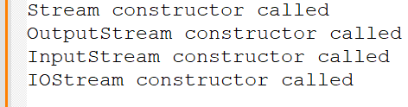

**Summary**

* **Virtual Pointers**: Used to manage virtual base class instances.
* **Diamond Inheritance**: Managed to prevent multiple instances of the base class.
* **Single Instance of Virtual Base Class**: Ensures consistency and avoids duplication.
* **Constructor Invocation**: Ensures the virtual base class is initialized only once by the most derived class.

Virtual inheritance in C++ is a powerful feature that helps manage multiple inheritance scenarios effectively, ensuring that base class instances are not duplicated and constructors are called appropriately.

the implementation of the **Stream**, **outputstream**, **inputstream**, and **iostream** classes as described, incorporating virtual inheritance to resolve the diamond inheritance problem.

**Implementation Details**

**Stream Class**

This class serves as the base class for both input and output streams.

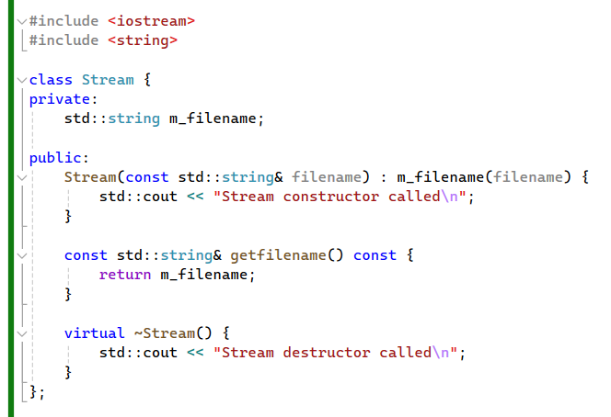

**outputstream Class**

This class represents an output stream, inheriting virtually from **Stream**.

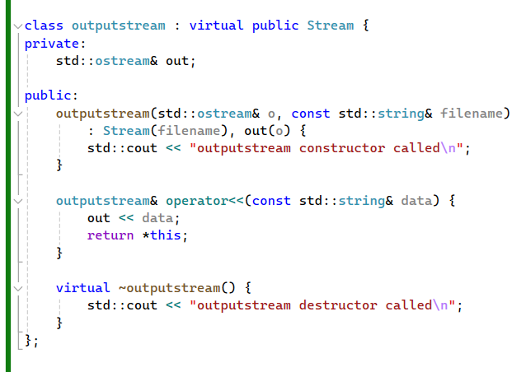

**inputstream Class**

This class represents an input stream, also inheriting virtually from **Stream**.

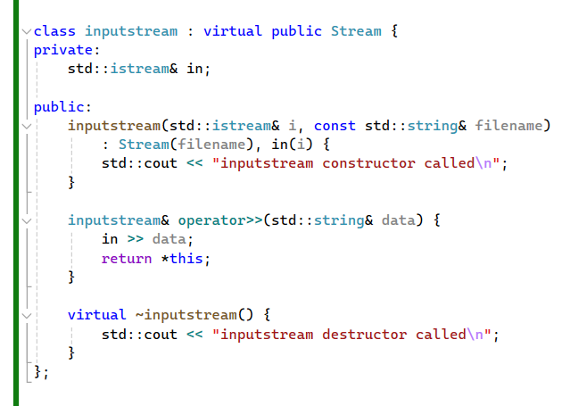

**iostream Class**

This class combines both input and output streams, inheriting from both **outputstream** and **inputstream**.

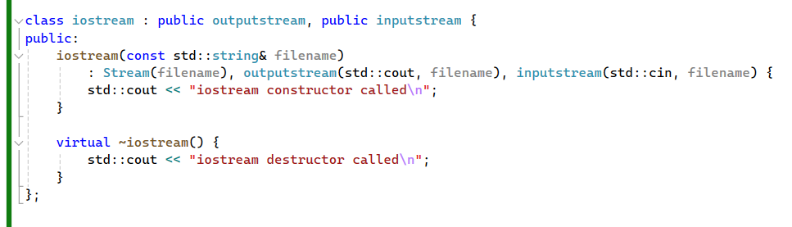

**run() Function**

This function demonstrates the usage of the **iostream** class.

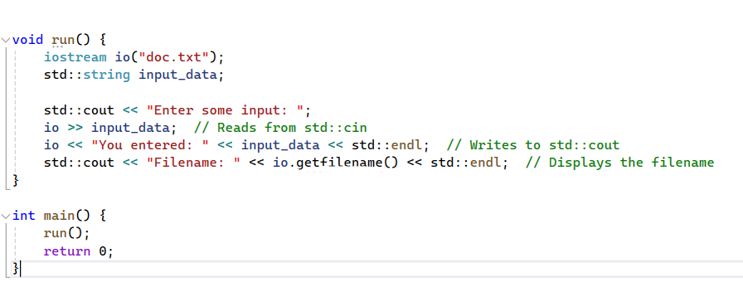

**Explanation**

1. **Stream Class**:
   * This class has a private member **m_filename** to store the filename.
   * The constructor initializes **m_filename** with the provided filename.
   * **getfilename()** returns a reference to the filename.
   * The destructor prints a message when the object is destroyed.
2. **outputstream Class**:
   * Inherits virtually from **Stream**.
   * Contains a reference to **std::ostream** for output operations.
   * The constructor initializes the **out** member and calls the base class constructor.
   * Overloads the **operator<<** to write data to the output stream.
   * The destructor prints a message upon destruction.
3. **inputstream Class**:
   * Inherits virtually from **Stream**.
   * Contains a reference to **std::istream** for input operations.
   * The constructor initializes the **in** member and calls the base class constructor.
   * Overloads the **operator>>** to read data from the input stream.
   * The destructor prints a message upon destruction.
4. **iostream Class**:
   * Inherits from both **outputstream** and **inputstream**.
   * The constructor initializes the **Stream** base class, **outputstream** with **std::cout**, and **inputstream** with **std::cin**.
   * The destructor prints a message upon destruction.
5. **run() Function**:
   * Creates an **iostream** object with the filename "doc.txt".
   * Reads input from **std::cin**, writes output to **std::cout**, and displays the filename using **getfilename()**.

**Ambiguity Resolution**

By using virtual inheritance, we ensure that only one instance of the **Stream** class is created and shared across the **outputstream** and **inputstream** classes. This avoids ambiguity and ensures consistent function resolution when accessing members of **Stream** from **iostream**.

**Multiple Inheritance and Diamond Problem**

**Multiple Inheritance**

* A class can inherit from more than one class simultaneously.
* This allows combining behaviors from different classes.

**Diamond Problem**

* Occurs when two parent classes inherit from a common base class.
* Forms a diamond shape in the inheritance hierarchy, leading to potential issues.

**Example: Stream, OutputStream, InputStream, IOStream**

1. **Stream Class**:
   * Contains attributes and methods for handling files.
2. **OutputStream Class**:
   * Inherits from Stream and provides writing functionality.
3. **InputStream Class**:
   * Inherits from Stream and provides reading functionality.
4. **IOStream Class**:
   * Inherits from both OutputStream and InputStream to enable both reading and writing.

**Problems in Diamond Inheritance**

* Creating an IOStream object results in two instances of Stream.
* This can cause issues such as:
  + File being opened twice.
  + Ambiguity when accessing methods from Stream (e.g., calling GetFilename()).

**Solution with Virtual Inheritance**

* Use virtual inheritance to ensure only one instance of Stream in IOStream.
* OutputStream and InputStream inherit from Stream virtually.

**How Virtual Inheritance Works**

1. **Single Instance of Stream**:
   * Virtual inheritance ensures that only one instance of the base class (Stream) exists in the derived class (IOStream).
2. **Constructor Sequence**:
   * The constructor of the most derived class (IOStream) directly invokes the base class (Stream) constructor.
   * Constructors of OutputStream and InputStream do not invoke the Stream constructor again.
3. **Virtual Pointers**:
   * Virtual pointers in OutputStream and InputStream point to the single instance of Stream within IOStream.

**Benefits of Virtual Inheritance**

* Eliminates redundancy by ensuring a single instance of the common base class.
* Resolves ambiguity in method access.
* Prevents potential issues related to multiple instances.

**Conclusion**

* Virtual inheritance is an effective way to solve the diamond problem in multiple inheritance.
* It ensures a clean, unambiguous inheritance hierarchy, allowing safe and predictable behavior in derived classes.

**Handling Ambiguity with Multiple Inheritance**

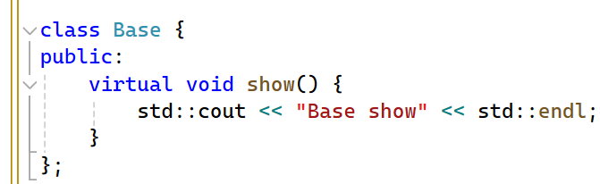

**Base Class**

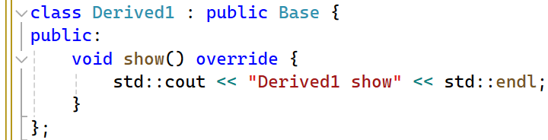

**Derived Classes**

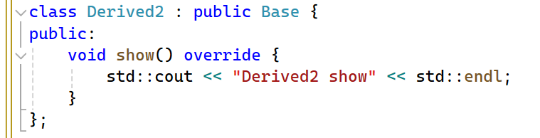

**Final Class**

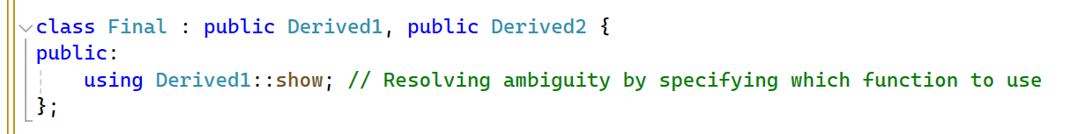

**Main Function to Demonstrate Ambiguity Resolution**

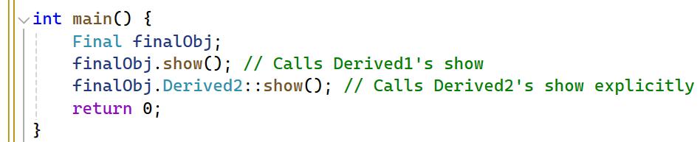

By using virtual inheritance and resolving function ambiguity, you can effectively manage complex multiple inheritance scenarios in C++, ensuring that your program remains clean, maintainable, and free of redundancy and ambiguity issues.

**Discussion of Ambiguity with Multiple Inheritance**

When dealing with multiple inheritance, particularly when a class inherits from two base classes that have a common ancestor, ambiguity issues can arise. Consider the following scenario:

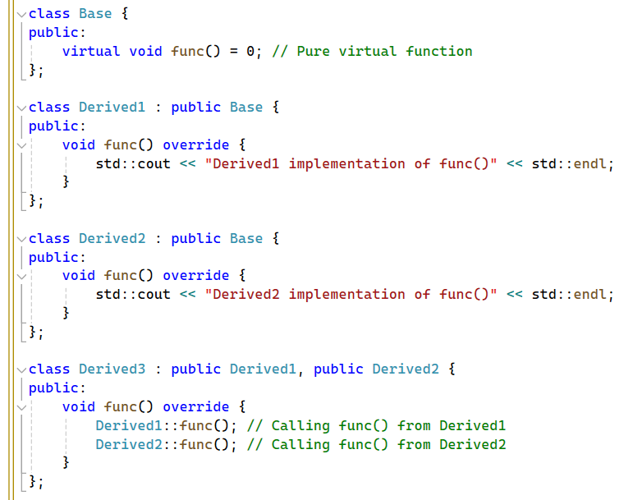

# `std::ostream`

Is a class in the C++ Standard Library that represents an output stream. It is part of the I/O stream library (`<iostream>`) and is used for sending formatted output to various output devices, such as the console, files, or other output streams.

1. **Purpose:** **`std::ostream`** is designed to handle output operations, allowing data to be formatted and sent to an output destination.
2. **Base Class: `std::ostream`** is a base class for various output stream classes in C++, including **`std::ofstream`** (file output stream), **`std::ostringstream`** (string output stream), and others.
3. **Functionality:**

* **Formatted Output:** It provides functions like **`operator<<`** for formatted output of data types such as integers, floating-point numbers, strings, and custom types.
* **Stream Manipulators:** It supports stream manipulators such as **`std::endl`, `std::setw`, `std::setprecision`,** etc., which control formatting options like line breaks, width, and precision.
* **State Management:** It maintains internal state flags to indicate the status of the stream, including error conditions like end-of-file or stream failure.

1. **Usage:**

* To use **`std::ostream`,** you typically include the **`<iostream>`** header file.
* You can create instances of **`std::ostream`** for different output destinations, such as `std::cout` for console output or **`std::ofstream`** for file output.
* Output operations are performed using the insertion operator (`<<`), which formats and sends data to the output stream.

Example:

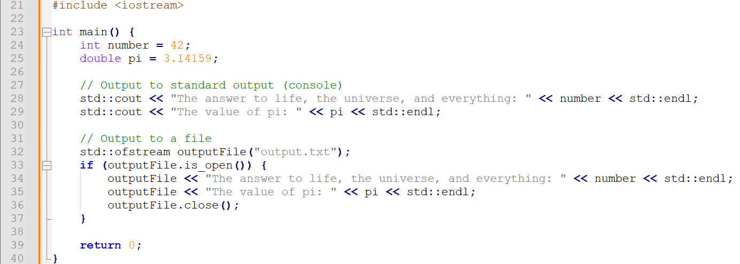

In this example, `std::cout` is an instance of `std::ostream` representing standard output (console), and `outputfile` is an instance of `std::ofstream` representing file output. Both are used for sending formatted output using the insertion operator (`<<`).

# `>>` and `<<`

In C++, `>>` and `<<` are called insertion and extraction operators, respectively. They are used for formatted input and output operations on streams. Here's what they mean in different contexts:

1. **Insertion Operator (`<<`):**

* The insertion operator `<<` is primarily used for output operations.
* It takes two operands: the left-hand side (LHS) operand is typically an output stream (e.g., `std::cout`, `std::ofstream`), and the right-hand side (RHS) operand can be any data that can be formatted into a string.
* It sends the data on the RHS to the output stream specified on the LHS.

- For example:

Std::cout << "Hello, World!";

1. **Extraction Operator (`>>`):**

* The extraction operator `>>` is primarily used for input operations.
* It takes two operands: the left-hand side (LHS) operand is typically an input stream (e.g., `std::cin`, `std::ifstream`), and the right-hand side (RHS) operand is a variable or reference where the input data will be stored.
* It reads data from the input stream specified on the LHS and stores it in the variable or reference specified on the RHS.

**- For example:**

Int number;

Std::cin >> number;

In summary, `<<` is used to output data to a stream, while `>>` is used to input data from a stream. These operators are fundamental in performing input and output operations in C++ and are commonly used with standard input and output streams (`std::cin`, `std::cout`), as well as file streams (`std::ifstream`, `std::ofstream`).